========================== Spring Data JPA ===============================

What is Spring Data JPA?
Spring Data JPA is a part of the Spring Framework that makes it easier to work with JPA (Java Persistence API). It simplifies database interactions by reducing boilerplate code for CRUD operations.

Key Points:
- Abstraction Over JPA – Simplifies working with JPA by reducing the need for writing queries.
- Repository Interface – Provides built-in methods like save(), findById(), findAll(), and delete().
- Query Methods – Allows creating queries just by defining method names (e.g., findByName(String name)).
- JPQL and Native Queries – Supports custom queries using JPQL or native SQL.
- Pagination and Sorting – Easy implementation of paging and sorting.

Example:
public interface UserRepository extends JpaRepository<User, Long> {
List<User> findByName(String name);
}
With this, Spring Data JPA will generate a query like:
SELECT * FROM users WHERE name = ?;

Why Use It?
✅ Reduces boilerplate code
✅ Improves maintainability
✅ Provides powerful query capabilities

Main Annotations Used in Spring Data JPA ?
In Spring Data JPA, several annotations are commonly used to define entities, map relationships, and configure repositories. Below is a list of the most important ones:

1. Entity & Table Mapping

@Entity
- Marks a class as a JPA entity (table in the database).
@Entity
public class User {
@Id
@GeneratedValue(strategy = GenerationType.IDENTITY)
private Long id;
private String name;
}

@Table(name = "user_table")
- Specifies the table name in the database.
@Entity
@Table(name = "users")
public class User { }

2. Primary Key & Auto-Generation

@Id
- Marks a field as the primary key.

@GeneratedValue(strategy = GenerationType.IDENTITY)
- Specifies that the ID should be auto-generated by the database.
@Id
@GeneratedValue(strategy = GenerationType.IDENTITY)
private Long id;

3. Column Mapping

@Column(name = "username", length = 50, nullable = false, unique = true)
- Maps a field to a column with custom properties.
@Column(name = "username", length = 50, nullable = false, unique = true)
private String name;

@Transient
- Prevents a field from being persisted in the database.
@Transient
private String temporaryData;

4. Relationship Mapping

@OneToOne
- Defines a one-to-one relationship.
@OneToOne
@JoinColumn(name = "address_id")
private Address address;

@OneToMany
- Defines a one-to-many relationship.
@OneToMany(mappedBy = "user", cascade = CascadeType.ALL)
private List<Order> orders;

@ManyToOne
- Defines a many-to-one relationship.
@ManyToOne
@JoinColumn(name = "user_id")
private User user;

@ManyToMany
- Defines a many-to-many relationship.
@ManyToMany
@JoinTable(name = "user_roles",
joinColumns = @JoinColumn(name = "user_id"),
inverseJoinColumns = @JoinColumn(name = "role_id"))
private List<Role> roles;

5. Repository Annotations

@Repository
- Marks an interface as a Spring Data repository.
@Repository
public interface UserRepository extends JpaRepository<User, Long> { }

@Query
- Defines custom JPQL or native SQL queries.
@Query("SELECT u FROM User u WHERE u.name = ?1")
List<User> findByName(String name);

@Modifying
- Used for UPDATE and DELETE queries.
@Modifying
@Query("UPDATE User u SET u.name = ?1 WHERE u.id = ?2")
void updateUserName(String name, Long id);

6. Transaction Management

@Transactional
- Ensures a method executes within a transaction.
@Transactional
public void saveUser(User user) {
userRepository.save(user);
}

Most Commonly Asked Interview Questions
What is @Entity annotation used for?
→ It marks a class as a JPA entity, meaning it will be mapped to a database table.
What is the difference between @OneToOne, @OneToMany, and @ManyToMany?
→ @OneToOne: One entity is related to only one other entity.
→ @OneToMany: One entity is related to multiple entities.
→ @ManyToMany: Multiple entities are related to multiple entities.
When should you use @Transactional?
→ When you need to ensure database operations execute as a single unit (atomicity).

When should you use @Transactional?
When you need to ensure database operations execute as a single unit (atomicity). that means when every we are using save method to store the user details to database at that time we need to use @Transactional right?
Good question! The short answer is not always. You don't need @Transactional for simple save() operations in Spring Data JPA because Spring Data JPA automatically wraps repository methods in a transaction when necessary.

When do you need @Transactional?
✅ For multiple database operations that should be executed as a single unit (atomicity).
✅ For methods that modify multiple entities together.
✅ For handling rollback scenarios in case of exceptions.
✅ For @Modifying queries in repositories.

When is @Transactional NOT required?
❌ Simple save(), findById(), or deleteById() calls do NOT need @Transactional because Spring Data JPA already manages transactions internally.

Example - When to use @Transactional

✅ Case 1: Multiple Operations in a Single Transaction
If you are saving a User and also updating their Order in the same method, you should use @Transactional to ensure either both succeed or both fail (atomicity).
@Service
public class UserService {

@Autowired
private UserRepository userRepository;

@Autowired
private OrderRepository orderRepository;

@Transactional
public void createUserWithOrder(User user, Order order) {
userRepository.save(user);
order.setUser(user);
orderRepository.save(order);
// If any exception occurs here, both `save` operations will be rolled back
}
}

✅ Case 2: @Modifying Query in Repository
When updating or deleting using a custom JPQL/SQL query, Spring requires @Transactional.
@Repository
public interface UserRepository extends JpaRepository<User, Long> {

@Modifying
@Transactional
@Query("UPDATE User u SET u.name = :name WHERE u.id = :id")
void updateUserName(@Param("name") String name, @Param("id") Long id);
}
Without @Transactional, this update may fail or not execute properly.

Example - When NOT to use @Transactional

❌ Case 1: Simple save() Operation
public void saveUser(User user) {
userRepository.save(user); // No need for @Transactional
}
Since save() is a single database operation, Spring Data JPA already wraps it in a transaction internally.

Key Takeaways for Interviews
- Spring Data JPA repository methods already use transactions where needed.
- Use @Transactional when multiple operations should be treated as a single unit.
- Custom @Modifying queries in repositories require @Transactional.
- Simple CRUD operations (save, findById, deleteById) do NOT require @Transactional.

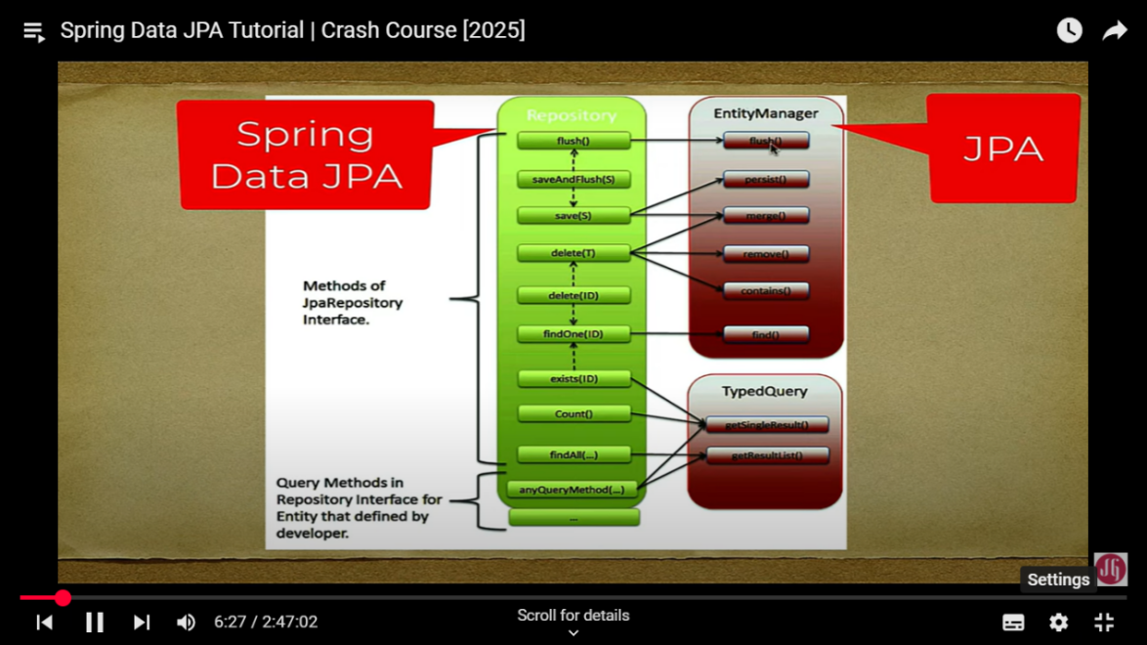

Spring Data JPA Architecture Flow ?
(Client Request)
⬇
Controller (REST API Layer)
⬇
Service (Business Logic Layer)
⬇
Repository (Spring Data JPA Interface)
⬇
JPA (EntityManager & Hibernate)
⬇
Database (MySQL, PostgreSQL, etc.)
Step-by-Step Explanation
Client Request
  - A user sends a request (e.g., HTTP GET, POST) to the Controller.
Controller Layer (@RestController)
  - Handles HTTP requests and delegates processing to the Service Layer.
Service Layer (@Service)
  - Contains business logic.
  - Calls the Repository Layer to interact with the database.
Repository Layer (@Repository or JpaRepository)
  - Uses Spring Data JPA to execute database queries.
  - Calls JPA’s EntityManager under the hood.
JPA (Java Persistence API) & Hibernate
  - JPA (Interface) provides an abstraction for database operations.
  - Hibernate (Implementation) converts JPA methods into actual SQL queries.
  - Communicates with the database using JDBC Driver.
Database (MySQL, PostgreSQL, etc.)
  - Executes queries and returns results to Hibernate → Repository → Service → Controller → Client.

Summary of Data Flow
- Repository Method Call →
- Spring Data JPA delegates to JPA (EntityManager) →
- JPA calls Hibernate (ORM Framework) →
- Hibernate generates and executes SQL queries →
- Database processes query & returns result →
- Hibernate maps result to Java Entity Object →
- Result is returned back to Repository → Service → Controller → Client
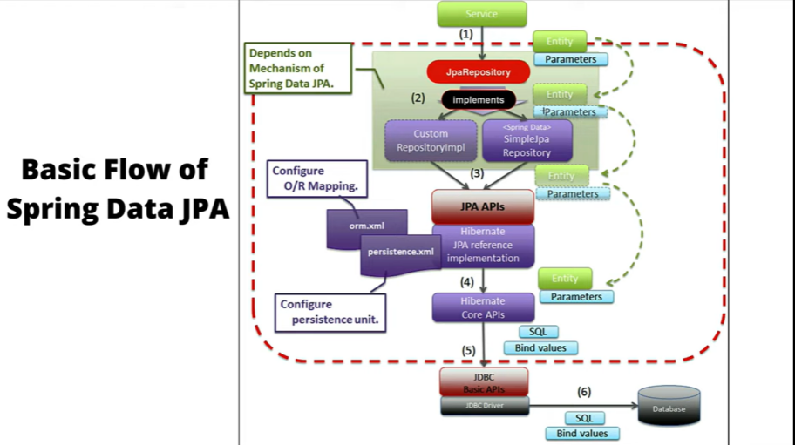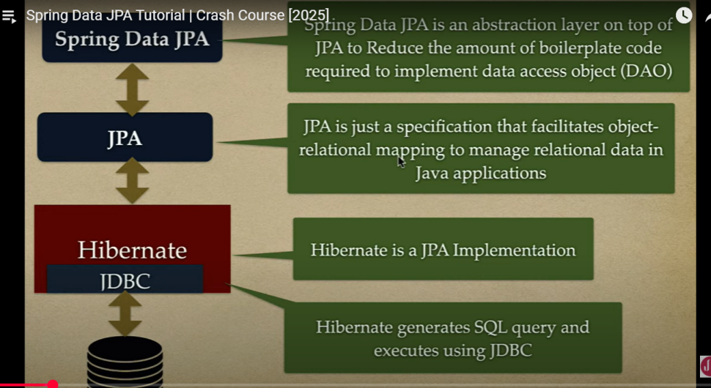
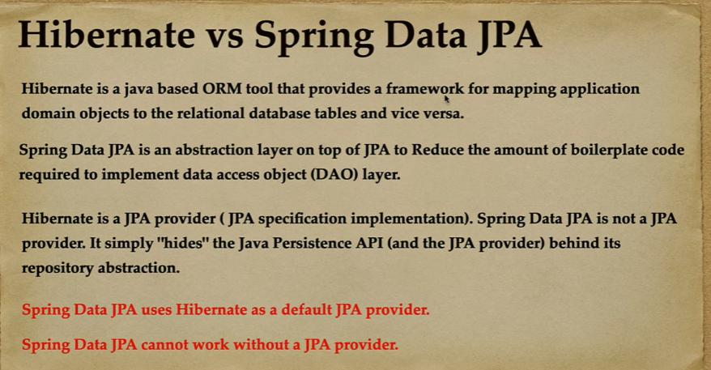
Example Entity class design
@Entity
@Table(
name = "products",
schema = "spring_data_jpa",
uniqueConstraints = {
@UniqueConstraint(
name = "sku_unique",
columnNames = "stock_keeping_unit"
)
}
)
public class Product {

@Id
@GeneratedValue(strategy = GenerationType.SEQUENCE,
generator = "product_generator"
)
@SequenceGenerator(
name = "product_generator",
sequenceName = "product_sequence_name",
allocationSize = 1
)
private Long id;
@Column(name = "stock_keeping_unit", nullable = false)
private String sku;
@Column(nullable = false)
private String name;
private String description;
private BigDecimal price;
private boolean active;
private String imageUrl;
@CreationTimestamp //
private LocalDateTime dateCreated;
@UpdateTimestamp
private LocalDateTime lastUpdated;
}
Entity class lo Primary Key ga difine chese column ki 4 types lo Primary key Generation strategie ni evachhu
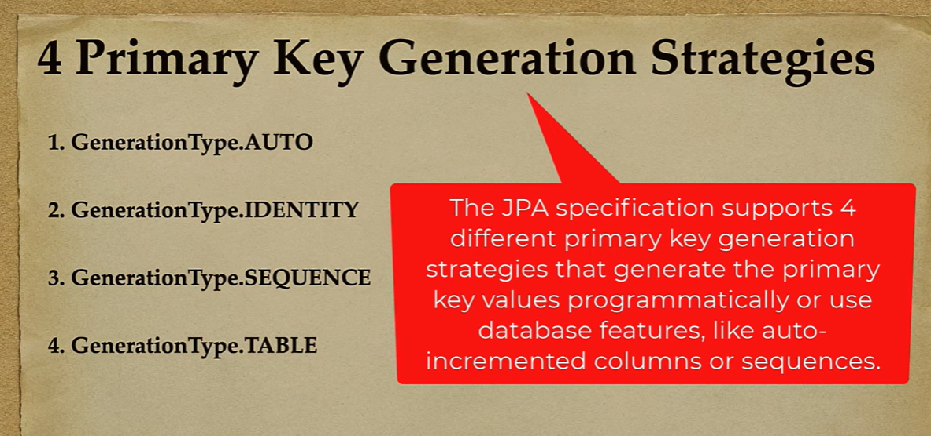

Primary Key Generation Strategies in Spring Data JPA
1️⃣ GenerationType.IDENTITY
- Uses auto-increment feature of the database.
- DB generates ID automatically when a new row is inserted.
- Best for MySQL & PostgreSQL.
- Example:
@Id
@GeneratedValue(strategy = GenerationType.IDENTITY)
private Long id;
- Pros: Simple & efficient for databases that support auto-increment.
- Cons: Can't batch insert because ID is generated after insert.
2️⃣ GenerationType.SEQUENCE
- Uses a database sequence to generate IDs.
- Best for databases like Oracle, PostgreSQL, etc.
- Example:
@Id
@GeneratedValue(strategy = GenerationType.SEQUENCE, generator = "user_seq")
@SequenceGenerator(name = "user_seq", sequenceName = "user_sequence", allocationSize = 1)
private Long id;
- Pros: Efficient, supports batch inserts.
- Cons: Not supported by MySQL (needs explicit sequence creation).
3️⃣ GenerationType.AUTO
- Spring chooses the best strategy based on the database.
- Example:
@Id
@GeneratedValue(strategy = GenerationType.AUTO)
private Long id;
- Pros: Portable across databases.
- Cons: Might behave differently in different databases.
4️⃣ GenerationType.TABLE
- Uses a separate database table to store and generate primary keys.
- Example:
@Id
@GeneratedValue(strategy = GenerationType.TABLE)
private Long id;
- Pros: Works with all databases.
- Cons: Slower compared to other strategies.

Which One is Best? (For Interview)
Strategy | Best For | Pros | Cons
IDENTITY | MySQL, PostgreSQL | Simple, automatic | No batch inserts
SEQUENCE | Oracle, PostgreSQL | Fast, supports batch inserts | Not supported in MySQL
AUTO | Any database | Portable | Behavior varies by DB
TABLE | Any database | Works everywhere | Slow, extra table needed
💡 For Interviews, Recommended Answer:
- Use IDENTITY for MySQL and SEQUENCE for databases that support it.
- AUTO is good for generic applications but might have unexpected behavior.
- Avoid TABLE because of performance overhead.

@CreationTimestamp & @UpdateTimestamp in Hibernate ?
✅ What Do They Do?
- @CreationTimestamp → Automatically sets the creation date/time when the entity is first saved.
- @UpdateTimestamp → Automatically updates the last modified date/time whenever the entity is updated.

Example:
import org.hibernate.annotations.CreationTimestamp;
import org.hibernate.annotations.UpdateTimestamp;

import java.time.LocalDateTime;
import jakarta.persistence.*;

@Entity
public class User {
@Id
@GeneratedValue(strategy = GenerationType.IDENTITY)
private Long id;

@CreationTimestamp
private LocalDateTime dateCreated;

@UpdateTimestamp
private LocalDateTime lastUpdated;
}

Alternatives to @CreationTimestamp & @UpdateTimestamp
If you don’t want to use Hibernate annotations, you can achieve the same behavior using:
1️⃣ Using JPA's @PrePersist & @PreUpdate Annotations
import jakarta.persistence.*;
import java.time.LocalDateTime;

@Entity
public class User {
@Id
@GeneratedValue(strategy = GenerationType.IDENTITY)
private Long id;

private LocalDateTime dateCreated;
private LocalDateTime lastUpdated;

@PrePersist
protected void onCreate() {
dateCreated = LocalDateTime.now();
lastUpdated = LocalDateTime.now();
}

@PreUpdate
protected void onUpdate() {
lastUpdated = LocalDateTime.now();
}
}
✅ Pros: Works with any JPA implementation (not Hibernate-specific).
❌ Cons: Requires manually setting timestamps.
2️⃣ Using Database Default Values (DEFAULT CURRENT_TIMESTAMP)
- If your database supports it, set default values at the DB level:
ALTER TABLE user
MODIFY date_created TIMESTAMP DEFAULT CURRENT_TIMESTAMP,
MODIFY last_updated TIMESTAMP DEFAULT CURRENT_TIMESTAMP ON UPDATE CURRENT_TIMESTAMP;
✅ Pros: No Java-side handling needed, managed entirely by the database.
❌ Cons: Less flexible if using different databases.

Which One is Best? (For Interview)
Approach | Pros | Cons
@CreationTimestamp & @UpdateTimestamp | Simple, automatic, works with Hibernate | Hibernate-specific
@PrePersist & @PreUpdate | Works with all JPA providers | Manual handling required
DB-Level Timestamps | No Java code needed, fast | DB-dependent, not flexible
💡 Best Practice (Recommended Answer in Interviews):
- Use @CreationTimestamp & @UpdateTimestamp if you are using Hibernate.
- Use @PrePersist & @PreUpdate for portability across different JPA providers.
- Use DB default values if you want timestamps managed at the database level.

Details of Spring Data and JPA repository Interfaces details ?
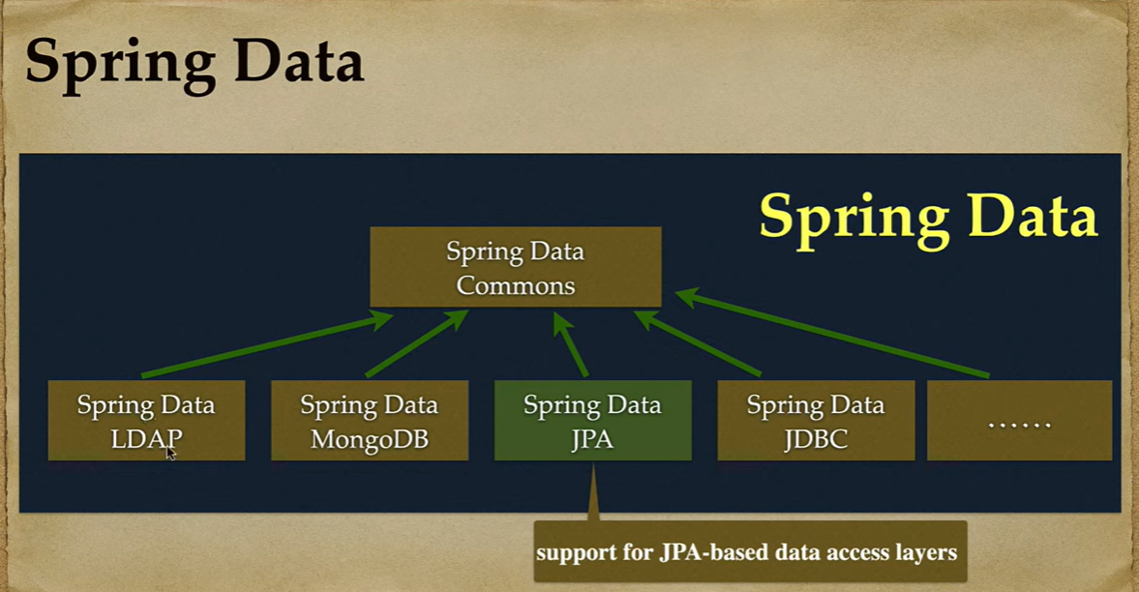
JPA repository Interfaces Flow ?
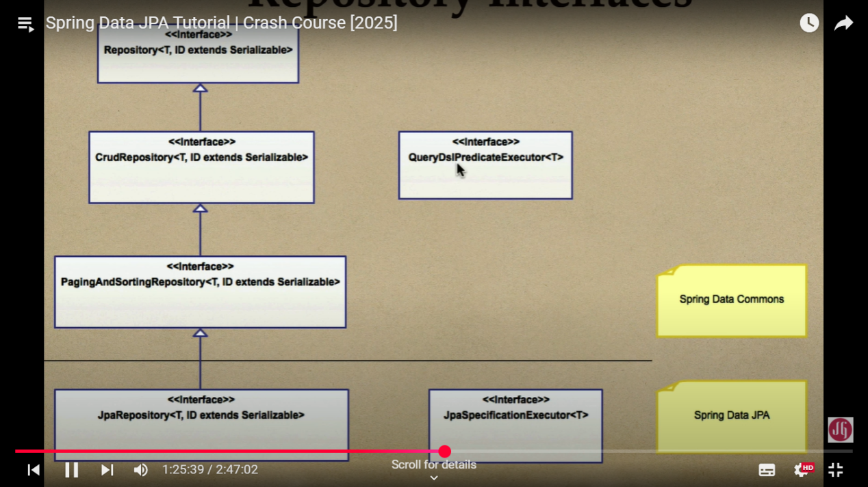
Spring Data JPA use chesetappudu manam JpaRepository ni EXtends chesethe saripothundi because JpaRepository anedi migilina anni interfaces ni extends chesthundi kanuka
Example of repository creation by using JpaRepository
public interface ProductRepository extends JpaRepository<Product, Long> {

Spring Data JPA – JpaRepository internal methods & custom methods and working Flow ?

✅ What is JpaRepository?
- JpaRepository<T, ID> is an interface provided by Spring Data JPA to perform database operations without writing boilerplate code.
- It does not directly connect to the database but internally uses JPA's EntityManager to communicate with the database.
- Hibernate (as the JPA implementation) translates JpaRepository methods into SQL queries.

1️⃣ Default Important Methods in JpaRepository
Spring Data JPA provides several built-in CRUD and query methods.

✅ Basic CRUD Operations
Method | Description
save(S entity) | Inserts or updates an entity.
saveAll(Iterable<S> entities) | Saves multiple entities at once.
findById(ID id) | Finds an entity by primary key.
findAll() | Retrieves all entities.
findAllById(Iterable<ID> ids) | Retrieves entities by multiple IDs.
delete(T entity) | Deletes an entity.
deleteById(ID id) | Deletes an entity by its ID.
deleteAll() | Deletes all entities.
existsById(ID id) | Checks if an entity exists by ID.
count() | Returns the total number of records.

2️⃣ How JpaRepository Methods Work Internally
- When you call userRepository.findById(1L), you are not directly running SQL.
- Instead, Spring Data JPA delegates the operation to JPA’s EntityManager, which Hibernate then converts into an SQL query.
- Example Flow:
Optional<User> user = userRepository.findById(1L);
- Internally, this does:
entityManager.find(User.class, 1L);
- Hibernate translates it into:
SELECT * FROM users WHERE id = 1;

3️⃣ Writing Custom Methods in JpaRepository
Apart from default methods, you can write custom queries using:
- Derived Query Methods (Method Naming)
- JPQL (@Query Annotation)
- Native SQL Queries
- Criteria API (Dynamic Queries)
JPA Query Techniques (JPQL, Native SQL, Criteria API)
Spring Data JPA provides three main ways to write queries:
1️⃣ Derived Query Methods (Method Naming)
2️⃣ JPQL (Java Persistence Query Language)
3️⃣ Native SQL Queries
4️⃣ Criteria API (Dynamic Queries)
Let’s go through each one with examples! 🚀

!)Derived Query Methods (Method Naming)
📌 Spring Data JPA automatically creates queries based on method names.

Example
List<User> findByName(String name); // SELECT * FROM users WHERE name = ?
List<User> findByAgeGreaterThan(int age); // SELECT * FROM users WHERE age > ?
List<User> findByNameAndAge(String name, int age); // SELECT * FROM users WHERE name = ? AND age = ?
🔹 Pros:
✅ No need to write SQL manually.
✅ Simple and readable.
🔹 Cons:
❌ Limited flexibility for complex queries.

!!)JPQL (Java Persistence Query Language)
📌 JPQL is similar to SQL but works with entity objects instead of tables.

Example
@Query("SELECT u FROM User u WHERE u.age > :age")
List<User> findUsersByAgeJPQL(@Param("age") int age);

Explanation:
- User is the entity name, not the table name.
- :age is a named parameter, which replaces ?1.

How Hibernate Converts This JPQL to SQL
SELECT * FROM users WHERE age > 25;
🔹 Pros:
✅ More powerful than method naming.
✅ Works with entity relationships (JOIN FETCH).
🔹 Cons:
❌ Still not ideal for very dynamic queries.

!!!) Native SQL Queries
📌 Native queries allow direct SQL execution.

Example
@Query(value = "SELECT * FROM users WHERE age > ?1", nativeQuery = true)
List<User> findUsersByAgeNative(int age);

How It Works
- ?1 is a positional parameter, replaced by method arguments.
- nativeQuery = true tells Spring this is raw SQL, not JPQL.
🔹 Pros:
✅ Full control over SQL (indexes, performance tuning).
✅ Can use database-specific SQL (like MySQL's LIMIT).
🔹 Cons:
❌ Less portable across databases.
❌ More prone to SQL injection (if parameters are not handled properly).

!V)Criteria API (For Dynamic Queries)
📌 Criteria API allows building queries dynamically in Java (without hardcoded SQL).

Example
import jakarta.persistence.criteria.*;
import org.springframework.stereotype.Repository;
import org.springframework.beans.factory.annotation.Autowired;
import jakarta.persistence.EntityManager;
import java.util.List;

@Repository
public class UserCriteriaRepository {

@Autowired
private EntityManager entityManager;

public List<User> findUsersByAgeGreaterThan(int age) {
CriteriaBuilder cb = entityManager.getCriteriaBuilder();
CriteriaQuery<User> query = cb.createQuery(User.class);
Root<User> root = query.from(User.class);

Predicate agePredicate = cb.greaterThan(root.get("age"), age);
query.where(agePredicate);

return entityManager.createQuery(query).getResultList();
}
}

Explanation:
- CriteriaBuilder dynamically creates conditions (WHERE age > ?).
- No hardcoded SQL—good for filtering with multiple conditions dynamically.
🔹 Pros:
✅ Good for complex dynamic queries (like search filters).
✅ Type-safe (reduces risk of SQL injection).
🔹 Cons:
❌ More verbose than JPQL.
❌ Harder to read compared to JPQL or native queries.

📌 Which Query Method is Best for Real-Time Projects?
There is no single "best" approach—it depends on the project requirements. Let’s compare them based on real-time usage.
✅ !) Derived Query Methods (Best for Simple Queries)
When to Use?
- When you need simple queries like findByName(), findByAgeGreaterThan().
- Works well for CRUD operations where the conditions are straightforward.
Example:
List<User> findByName(String name); // SELECT * FROM users WHERE name = ?
💡 Best for: Small projects, microservices, and basic CRUD.

✅ !!) JPQL (Best for Entity-Based Queries and Relationships)
When to Use?
- When you need queries that involve relationships (JOIN) between entities.
- When database portability (switching from MySQL to PostgreSQL, etc.) is needed.
Example:
@Query("SELECT u FROM User u WHERE u.age > :age")
List<User> findUsersByAge(@Param("age") int age);
💡 Best for: Enterprise applications, large-scale systems.

✅ !!!) Native SQL Queries (Best for Performance Optimization)
When to Use?
- When performance is a concern, and you need database-specific optimizations (like LIMIT, INDEX HINTS).
- When JPQL is not powerful enough for complex queries.
Example:
@Query(value = "SELECT * FROM users WHERE age > ?1", nativeQuery = true)
List<User> findUsersByAgeNative(int age);
💡 Best for: High-performance applications, reporting dashboards.

✅ !V) Criteria API (Best for Dynamic Filtering and Search)
When to Use?
- When queries need to be built dynamically (e.g., filtering by multiple fields at runtime).
- When search forms require optional filters.
Example:
public List<User> findUsersByAgeGreaterThan(int age) {
CriteriaBuilder cb = entityManager.getCriteriaBuilder();
CriteriaQuery<User> query = cb.createQuery(User.class);
Root<User> root = query.from(User.class);

Predicate agePredicate = cb.greaterThan(root.get("age"), age);
query.where(agePredicate);

return entityManager.createQuery(query).getResultList();
}
💡 Best for: Search filters, advanced reporting, dynamic queries.

🔥 Final Recommendation for Real-Time Projects
Query Type | When to Use? | Best For
Derived Query Methods | Simple queries | Microservices, basic CRUD
JPQL | Queries with entity relationships | Enterprise applications
Native SQL Queries | Performance optimization | High-performance systems
Criteria API | Dynamic filtering | Search filters, reporting
Use Derived Queries for simple conditions.
Use JPQL when working with entities and relationships.
Use Native SQL when performance tuning is required.
Use Criteria API for dynamic queries and search filters.

🚀 Interview Answer Summary
"In real-time projects, we use a combination of Derived Queries, JPQL, Native SQL, and Criteria API. Derived Queries are best for simple operations, JPQL is great for entity relationships, Native SQL helps with performance tuning, and Criteria API is useful for dynamic search filters. We choose based on the project requirements."

4️⃣ How to Explain in Interviews?
Does JpaRepository directly interact with the database?
  - No, it uses JPA's EntityManager, which is implemented by Hibernate.
  - Hibernate converts repository method calls into SQL queries and interacts with the database.
What are the most important methods in JpaRepository?
  - CRUD methods: save(), findById(), findAll(), deleteById(), etc.
  - Query methods: findByName(), findByAgeGreaterThan(), etc.
How do you write custom methods in JpaRepository?
  - Method Naming (Derived Queries) → findByName(String name).
  - JPQL (@Query) → @Query("SELECT u FROM User u WHERE u.age > :age").
  - Native SQL Queries → @Query(value = "SELECT * FROM users WHERE age > ?1", nativeQuery = true).
  - Criteria API → For dynamic queries using EntityManager.
Which approach is best?
  - Use derived queries for simple queries.
  - Use @Query (JPQL) for flexibility and cross-DB compatibility.
  - Use native SQL for complex queries that need DB-specific features.
  - Use Criteria API for dynamic conditions.

Final Summary (Best Interview Answer)
"JpaRepository does not directly interact with the database; it uses JPA’s EntityManager, which is implemented by Hibernate. JpaRepository provides built-in CRUD methods like save(), findById(), and deleteById(). We can also write custom queries using method naming, @Query (JPQL), native SQL, or Criteria API. The best approach depends on the complexity of the query and database compatibility."
Would you like a real project example implementing these concepts?

📌 Spring Boot + Spring Data JPA Full Example
This example covers:
✅ JpaRepository CRUD operations
✅ Custom queries using Method Naming, JPQL, and Native SQL
✅ How JpaRepository interacts with EntityManager internally

1️⃣ Setup – Add Dependencies
📌 Add these dependencies in pom.xml (for Maven projects):
<dependencies>
<!-- Spring Boot JPA Starter -->
<dependency>
<groupId>org.springframework.boot</groupId>
<artifactId>spring-boot-starter-data-jpa</artifactId>
</dependency>

<!-- MySQL Driver -->
<dependency>
<groupId>mysql</groupId>
<artifactId>mysql-connector-java</artifactId>
<scope>runtime</scope>
</dependency>

<!-- Spring Boot Starter Web (For REST API) -->
<dependency>
<groupId>org.springframework.boot</groupId>
<artifactId>spring-boot-starter-web</artifactId>
</dependency>
</dependencies>

2️⃣ Configure application.properties (MySQL)
📌 Configure MySQL database in src/main/resources/application.properties:
spring.datasource.url=jdbc:mysql://localhost:3306/mydatabase
spring.datasource.username=root
spring.datasource.password=yourpassword
spring.datasource.driver-class-name=com.mysql.cj.jdbc.Driver

# Hibernate Properties
spring.jpa.database-platform=org.hibernate.dialect.MySQL8Dialect
spring.jpa.hibernate.ddl-auto=update
spring.jpa.show-sql=true
🔹 spring.jpa.hibernate.ddl-auto=update → Automatically updates table schema.

3️⃣ Create User Entity
📌 Define the entity class that maps to the users table.
import jakarta.persistence.*;
import lombok.*;

import java.time.LocalDateTime;

@Entity
@Table(name = "users")
@Getter
@Setter
@NoArgsConstructor
@AllArgsConstructor
public class User {
@Id
@GeneratedValue(strategy = GenerationType.IDENTITY)
private Long id;

private String name;
private int age;

@Column(unique = true)
private String email;

@CreationTimestamp
private LocalDateTime createdAt;

@UpdateTimestamp
private LocalDateTime updatedAt;
}
🔹 Auto-generated fields: id, createdAt, and updatedAt.
🔹 JPA annotations: @Entity, @Table, @Id, @GeneratedValue.

4️⃣ Create UserRepository (JpaRepository CRUD & Custom Queries)
📌 Extend JpaRepository<User, Long> for default methods + add custom queries.
import org.springframework.data.jpa.repository.JpaRepository;
import org.springframework.data.jpa.repository.Query;
import org.springframework.stereotype.Repository;

import java.util.List;

@Repository
public interface UserRepository extends JpaRepository<User, Long> {

// ✅ Derived Query Methods (Method Naming)
List<User> findByName(String name); // SELECT * FROM users WHERE name = ?

List<User> findByAgeGreaterThan(int age); // SELECT * FROM users WHERE age > ?

// ✅ JPQL Query (Using Entity Name, not Table)
@Query("SELECT u FROM User u WHERE u.email = :email")
User findByEmail(String email);

// ✅ Native SQL Query
@Query(value = "SELECT * FROM users WHERE age > ?1", nativeQuery = true)
List<User> findUsersByAgeNative(int age);
}
🔹 Derived Queries: findByName(), findByAgeGreaterThan().
🔹 JPQL Query (@Query) → Uses entity name (User).
🔹 Native SQL Query → Uses raw SQL (nativeQuery = true).

5️⃣ Create UserService (Business Logic Layer)
📌 Service class to handle business logic before calling the repository.
import org.springframework.beans.factory.annotation.Autowired;
import org.springframework.stereotype.Service;

import java.util.List;
import java.util.Optional;

@Service
public class UserService {

@Autowired
private UserRepository userRepository;

// Create User
public User saveUser(User user) {
return userRepository.save(user);
}

// Get All Users
public List<User> getAllUsers() {
return userRepository.findAll();
}

// Find by ID
public Optional<User> getUserById(Long id) {
return userRepository.findById(id);
}

// Find by Name (Custom Query)
public List<User> getUsersByName(String name) {
return userRepository.findByName(name);
}

// Delete User
public void deleteUser(Long id) {
userRepository.deleteById(id);
}

// age
public List<User> getUsersByAgeNative(int age) {
return userRepository.findUsersByAgeNative(age);
}

}
🔹 Calls JpaRepository methods internally.
🔹 Handles CRUD operations and query methods.

6️⃣ Create UserController (REST API)
📌 Exposes API endpoints for CRUD operations.
import org.springframework.beans.factory.annotation.Autowired;
import org.springframework.web.bind.annotation.*;

import java.util.List;
import java.util.Optional;

@RestController
@RequestMapping("/users")
public class UserController {

@Autowired
private UserService userService;

// Create User (POST)
@PostMapping
public User createUser(@RequestBody User user) {
return userService.saveUser(user);
}

// Get All Users (GET)
@GetMapping
public List<User> getAllUsers() {
return userService.getAllUsers();
}

// Get User by ID (GET)
@GetMapping("/{id}")
public Optional<User> getUserById(@PathVariable Long id) {
return userService.getUserById(id);
}

// Get Users by Name (GET)
@GetMapping("/name/{name}")
public List<User> getUsersByName(@PathVariable String name) {
return userService.getUsersByName(name);
}

// Delete User (DELETE)
@DeleteMapping("/{id}")
public String deleteUser(@PathVariable Long id) {
userService.deleteUser(id);
return "User deleted successfully!";
}

// ✅ New API: Get Users Older Than a Certain Age (Native Query)
@GetMapping("/age/{age}")
public List<User> getUsersByAge(@PathVariable int age) {
return userService.getUsersByAgeNative(age);
}

}
🔹 RESTful API for POST, GET, DELETE operations.
🔹 Uses @RestController to expose API endpoints.

7️⃣ How Methods Interact with Database
✅ Example: Fetch user by ID (findById)
- Controller calls userService.getUserById(id).
- UserService calls userRepository.findById(id).
- JpaRepository delegates to EntityManager.find(User.class, id).
- Hibernate translates it into:
SELECT * FROM users WHERE id = ?;

- DB executes SQL → Result mapped to Java object → Returned to API.
✅ Example: Save user (save)
- userService.saveUser(user) → calls userRepository.save(user).
- JpaRepository.save() calls EntityManager.persist(user).
- Hibernate generates:
INSERT INTO users (name, age, email) VALUES (?, ?, ?);
- DB inserts data, Hibernate returns the saved entity.

📌 Testing with Postman or Curl

1️⃣ Create a New User (POST)
curl -X POST http://localhost:8080/users \
-H "Content-Type: application/json" \
-d '{"name":"John", "age":30, "email":"john@example.com"}'

2️⃣ Get All Users (GET)
curl -X GET http://localhost:8080/users

3️⃣ Find User by Name (GET)
curl -X GET http://localhost:8080/users/name/John
4️⃣ Delete User (DELETE)
curl -X DELETE http://localhost:8080/users/1

5 Find Users Older Than 25
curl -X GET http://localhost:8080/users/age/25

This will execute the native SQL query:
SELECT * FROM users WHERE age > 25;

✅ Returns a list of users older than 25.

Interview Summary Answer
"JpaRepository is an abstraction that provides built-in CRUD operations, but internally it delegates to EntityManager, which Hibernate uses to execute SQL queries. We can create custom queries using method naming, JPQL, native SQL, and Criteria API. The best approach depends on performance and flexibility requirements."
Done! Your Spring Boot + JPA Project is Ready!

Native Query lo WHERE age > ?1 ani rasam kada why we need to use 1 and what is the use

@Query(value = "SELECT * FROM users WHERE age > ?1", nativeQuery = true)
List<User> findUsersByAgeNative(int age);

Great question! Let me explain ?1 in the query:

📌 What Does ?1 Mean in the Query?
The ?1 is a positional parameter in the query. It means:
- The first parameter passed to the method (findUsersByAgeNative(int age)) will replace ?1 at runtime.
- If there were multiple parameters, you would use ?2, ?3, etc., for the second and third parameters.

📌 Example: How It Works?

Query Definition in Repository
@Query(value = "SELECT * FROM users WHERE age > ?1", nativeQuery = true)
List<User> findUsersByAgeNative(int age);
🔹 Here, ?1 will be replaced by the method parameter age.

Example API Call
curl -X GET http://localhost:8080/users/age/25

Query Execution in Database
When we call findUsersByAgeNative(25), Hibernate replaces ?1 with 25 and executes:
SELECT * FROM users WHERE age > 25;
✅ Returns a list of users older than 25.

📌 If We Had Multiple Parameters?
If the query had two conditions, you would use ?1 and ?2.

Example Query
@Query(value = "SELECT * FROM users WHERE age > ?1 AND name = ?2", nativeQuery = true)
List<User> findUsersByAgeAndName(int age, String name);

Example API Call
curl -X GET http://localhost:8080/users/age-name/25/John

Query Execution
SELECT * FROM users WHERE age > 25 AND name = 'John';
✅ Finds users older than 25 with the name "John".

📌 Alternative: Named Parameters (:age)
Instead of using ?1, we can use named parameters (:age):
@Query(value = "SELECT * FROM users WHERE age > :age", nativeQuery = true)
List<User> findUsersByAgeNative(@Param("age") int age);
🔹 Now, :age will be replaced by the parameter value instead of ?1.

📌 Interview Answer Summary
"?1 is a positional parameter in a JPA query, which is replaced by the first method argument at runtime. If there are multiple parameters, we use ?2, ?3, etc. Alternatively, we can use named parameters (:paramName) for better readability."

After extends JpaRepository we can write some default Internal Methods in interfaces
Ex :- kinda vunna Interface loni menthods lo konni internal methods and konni custom methods vunnai

public interface ProductRepository extends JpaRepository<Product, Long> {
public Product findByName(String name);
Optional<Product> findById(Long id);
List<Product> findByNameOrDescription(String name, String description);
List<Product> findByNameAndDescription(String name, String description);
Product findDistinctByName(String name);
List<Product> findByPriceGreaterThan(BigDecimal price);
List<Product> findByPriceLessThan(BigDecimal price);
List<Product> findByNameContaining(String name);
List<Product> findByNameLike(String name);
List<Product> findByPriceBetween(BigDecimal startPrice, BigDecimal endPrice);
List<Product> findByDateCreatedBetween(LocalDateTime startDate, LocalDateTime endDate);
List<Product> findByNameIn(List<String> names);
List<Product> findFirst2ByOrderByNameAsc();
List<Product> findTop2ByOrderByPriceDesc();
// Define JPQL query using @Query annotation with index or position parameters
@Query("SELECT p from Product p where p.name = ?1 or p.description = ?2")
Product findByNameOrDescriptionJPQLIndexParam(String name, String description);
// Define JPQL query using @Query annotation with Named parameters
@Query("SELECT p from Product p where p.name = :name or p.description = :description")
Product findByNameOrDescriptionJPQLNamedParam(@Param("name") String name,
@Param("description") String description);
// Define Native SQL query using @Query annotation with index or position parameters
@Query(value = "select * from products p where p.name = ?1 or p.description = ?2", nativeQuery = true)
Product findByNameOrDescriptionSQLIndexParam(String name, String description);
// Define Native SQL query using @Query annotation with Named parameters
@Query(value = "select * from products p where p.name = :name or p.description = :description"
, nativeQuery = true)
Product findByNameOrDescriptionSQLNamedParam(@Param("name") String name,
@Param("description") String description);
// Define Named JPQL query
Product findByPrice(@Param("price") BigDecimal price);
List<Product> findAllOrderByNameDesc();
// Define Named native SQL query
@Query(nativeQuery = true)
Product findByDescription(@Param("description") String description);
List<Product> findAllOrderByNameASC();
}

Explanations and clarity about Internal methods

Internal Methods & Naming Convention (Provided by Spring Data JPA):
These methods are automatically implemented by Spring Data JPA based on the method signature and naming conventions. You don’t need to manually implement them

Internal Methods Naming convention
In Spring Data JPA, the method names must follow specific naming conventions in order to automatically generate the queries. It is mandatory to use a standardized naming pattern so that Spring Data JPA can map your method names to the corresponding database queries.

General Naming Conventions:
findBy<field>: This is used to find an entity based on a single field.
  - Example: findById(Long id) — finds a product by its id.
  - Example: findByName(String name) — finds a product by its name.
findBy<field>And<anotherField>: Finds entities by multiple fields.
  - Example: findByNameAndDescription(String name, String description) — finds products that match both name and description.
findBy<field>Or<anotherField>: Finds entities where one of the fields matches.
  - Example: findByNameOrDescription(String name, String description) — finds products where the name or description matches.
findBy<field>Containing: Used for partial matching or substring search.
  - Example: findByNameContaining(String name) — finds products whose name contains the provided substring.
findBy<field>LessThan: Finds entities where a field is less than a given value.
  - Example: findByPriceLessThan(BigDecimal price) — finds products whose price is less than the given value.
findBy<field>GreaterThan: Finds entities where a field is greater than a given value.
  - Example: findByPriceGreaterThan(BigDecimal price) — finds products whose price is greater than the given value.
findBy<field>Between: Finds entities where a field value is within a range.
  - Example: findByPriceBetween(BigDecimal startPrice, BigDecimal endPrice) — finds products whose price is between two values.
findBy<field>In: Finds entities where a field value is in a given list of values.
  - Example: findByNameIn(List<String> names) — finds products whose name is in the provided list.
findFirst<Number>ByOrderBy<field>: Finds a limited number of entities ordered by a field.
  - Example: findFirst2ByOrderByNameAsc() — finds the first two products ordered by name in ascending order.
findTop<Number>ByOrderBy<field>: Similar to findFirst, but used to find the "top" results.
  - Example: findTop2ByOrderByPriceDesc() — finds the top 2 products ordered by price in descending order.

Custom Methods & Naming Convention (JPQL/Native SQL Queries):
These are custom methods where you're explicitly defining JPQL (Java Persistence Query Language) or SQL queries using the @Query annotation.
findByNameOrDescriptionJPQLIndexParam(String name, String description)
  - Purpose: Uses a JPQL query to find a product by either name or description using index parameters (?1, ?2).
  - Return Type: A single Product (or null if not found).
findByNameOrDescriptionJPQLNamedParam(String name, String description)
  - Purpose: Uses a JPQL query with named parameters (:name, :description) to find a product by either name or description.
  - Return Type: A single Product.
findByNameOrDescriptionSQLIndexParam(String name, String description)
  - Purpose: Uses a native SQL query with index parameters to find a product by either name or description.
  - Return Type: A single Product.
findByNameOrDescriptionSQLNamedParam(String name, String description)
  - Purpose: Uses a native SQL query with named parameters to find a product by either name or description.
  - Return Type: A single Product.
findByPrice(BigDecimal price)
  - Purpose: Custom method (you can also use the default findByPriceGreaterThan or findByPriceLessThan methods for price-based queries).
  - Return Type: A Product (the method name suggests this could be returning only a single product based on price, which can be confusing).
findAllOrderByNameDesc()
  - Purpose: Finds all products ordered by name in descending order.
  - Return Type: A list of Product objects.
findByDescription(String description)
  - Purpose: Custom method to find a product by its description using a native SQL query.
  - Return Type: A single Product.
findAllOrderByNameASC()
  - Purpose: Finds all products ordered by name in ascending order.
  - Return Type: A list of Product objects.

Summary:
- Internal methods are built-in methods provided by Spring Data JPA based on naming conventions and the JpaRepository interface. These methods handle common CRUD operations automatically, like finding by ID, name, price, etc.
- Custom methods are those where you need specific, complex queries (like JPQL or SQL). These methods allow you to define your own query using the @Query annotation for more control.
Custom Methods Naming convention

Customizing Method Names:
While Spring Data JPA provides a lot of flexibility, the method names must follow this convention in order to be recognized and mapped to database queries.
- You cannot arbitrarily change the name of these methods to anything you want. For example, findProductByNameAndDescription() or findProductById() would not work unless you define custom queries with the @Query annotation (which we’ll cover below).

Custom Queries with @Query:
If you need more complex queries that can’t be captured by these conventions, you can use the @Query annotation to define a custom JPQL (Java Persistence Query Language) or native SQL query.
For example:
@Query("SELECT p FROM Product p WHERE p.name = ?1 AND p.price > ?2")
List<Product> findProductsByNameAndPriceGreaterThan(String name, BigDecimal price);
In this case, you can give the method any name you want (e.g., findProductsByNameAndPriceGreaterThan), but you will need to manually write the query using @Query.

Conclusion:
- For internal methods, the names must follow Spring Data JPA's naming conventions like findByName, findById, findByNameOrDescription, etc.
- You cannot use arbitrary names unless you are defining custom queries with @Query, where you can name the method whatever you want.
=================== Small project ================
Based on above Product Repo interfaces created Services and controller layers
Here is your Service Implementation and Controller that use all methods from the ProductRepository via the ProductServices_I interface.

📌 Service Interface
package com.Spring_Data_JPA.Services;

public interface ProductServices_I {
Product findByName(String name);
Optional<Product> findById(Long id);
List<Product> findByNameOrDescription(String name, String description);
List<Product> findByNameAndDescription(String name, String description);
Product findDistinctByName(String name);
List<Product> findByPriceGreaterThan(BigDecimal price);

List<Product> findByPriceLessThan(BigDecimal price);
List<Product> findByNameContaining(String name);
List<Product> findByNameLike(String name);
List<Product> findByPriceBetween(BigDecimal startPrice, BigDecimal endPrice);
List<Product> findByDateCreatedBetween(LocalDateTime startDate, LocalDateTime endDate);
List<Product> findByNameIn(List<String> names);
List<Product> findFirst2ByOrderByNameAsc();
List<Product> findTop2ByOrderByPriceDesc();
Product findByNameOrDescriptionJPQLIndexParam(String name, String description);
Product findByNameOrDescriptionJPQLNamedParam(String name, String description);
Product findByNameOrDescriptionSQLIndexParam(String name, String description);
Product findByNameOrDescriptionSQLNamedParam(String name, String description);
Product findByPrice(BigDecimal price);
List<Product> findAllByOrderByNameDesc();
Product findByDescription(String description);
List<Product> findAllByOrderByNameAsc();
}

📌 Service Implementation

@Service
public class ProductServiceImpl implements ProductServices_I{

@Autowired
private ProductRepository productRepository;

@Override
public Product findByName(String name) {
return productRepository.findByName(name);
}

@Override
public Optional<Product> findById(Long id) {
return productRepository.findById(id);
}

@Override
public List<Product> findByNameOrDescription(String name, String description) {
return productRepository.findByNameOrDescription(name, description);
}

@Override
public List<Product> findByNameAndDescription(String name, String description) {
return productRepository.findByNameAndDescription(name, description);
}

@Override
public Product findDistinctByName(String name) {
return productRepository.findDistinctByName(name);
}

@Override
public List<Product> findByPriceGreaterThan(BigDecimal price) {
return productRepository.findByPriceGreaterThan(price);
}

@Override
public List<Product> findByPriceLessThan(BigDecimal price) {
return productRepository.findByPriceLessThan(price);
}

@Override
public List<Product> findByNameContaining(String name) {
return productRepository.findByNameContaining(name);
}

@Override
public List<Product> findByNameLike(String name) {
return productRepository.findByNameLike(name);
}

@Override
public List<Product> findByPriceBetween(BigDecimal startPrice, BigDecimal endPrice) {
return productRepository.findByPriceBetween(startPrice, endPrice);
}

@Override
public List<Product> findByDateCreatedBetween(LocalDateTime startDate, LocalDateTime endDate) {
return productRepository.findByDateCreatedBetween(startDate, endDate);
}

@Override
public List<Product> findByNameIn(List<String> names) {
return productRepository.findByNameIn(names);
}

@Override
public List<Product> findFirst2ByOrderByNameAsc() {
return productRepository.findFirst2ByOrderByNameAsc();
}

@Override
public List<Product> findTop2ByOrderByPriceDesc() {
return productRepository.findTop2ByOrderByPriceDesc();
}

@Override
public Product findByNameOrDescriptionJPQLIndexParam(String name, String description) {
return productRepository.findByNameOrDescriptionJPQLIndexParam(name, description);
}

@Override
public Product findByNameOrDescriptionJPQLNamedParam(String name, String description) {
return productRepository.findByNameOrDescriptionJPQLNamedParam(name, description);
}

@Override
public Product findByNameOrDescriptionSQLIndexParam(String name, String description) {
return productRepository.findByNameOrDescriptionSQLIndexParam(name, description);
}

@Override
public Product findByNameOrDescriptionSQLNamedParam(String name, String description) {
return productRepository.findByNameOrDescriptionSQLNamedParam(name, description);
}

@Override
public Product findByPrice(BigDecimal price) {
return productRepository.findByPrice(price);
}

@Override
public List<Product> findAllByOrderByNameDesc() {
return productRepository.findAllByOrderByNameDesc();
}

@Override
public Product findByDescription(String description) {
return productRepository.findByDescription(description);
}

@Override
public List<Product> findAllByOrderByNameAsc() {
return productRepository.findAllByOrderByNameAsc();
}
}

📌 Controller Layer

@RestController
@RequestMapping("/products")
public class ProductController {

@Autowired
private ProductServices_I productService;

@GetMapping("/name/{name}")
public ResponseEntity<Product> getProductByName(@PathVariable String name) {
return ResponseEntity.ok(productService.findByName(name));
}

/* @GetMapping("/id/{id}")
public ResponseEntity<Optional<Product>> getProductById(@PathVariable Long id) {
return ResponseEntity.ok(productService.findById(id));
}*/

@GetMapping("/id/{id}")
public ResponseEntity<Product> getProductById(@PathVariable Long id) {
Optional<Product> product = productService.findById(id);
if (product.isPresent()) {
return ResponseEntity.ok(product.get());
} else {
return ResponseEntity.notFound().build();
}
}

@GetMapping("/search")
public ResponseEntity<List<Product>> getProductsByNameOrDescription(
@RequestParam String name,
@RequestParam String description) {
return ResponseEntity.ok(productService.findByNameOrDescription(name, description));
}

@GetMapping("/price/greater/{price}")
public ResponseEntity<List<Product>> getProductsByPriceGreaterThan(@PathVariable BigDecimal price) {
return ResponseEntity.ok(productService.findByPriceGreaterThan(price));
}

@GetMapping("/price/less/{price}")
public ResponseEntity<List<Product>> getProductsByPriceLessThan(@PathVariable BigDecimal price) {
return ResponseEntity.ok(productService.findByPriceLessThan(price));
}

@GetMapping("/price/between")
public ResponseEntity<List<Product>> getProductsByPriceBetween(
@RequestParam BigDecimal startPrice,
@RequestParam BigDecimal endPrice) {
return ResponseEntity.ok(productService.findByPriceBetween(startPrice, endPrice));
}

@GetMapping("/date/between")
public ResponseEntity<List<Product>> getProductsByDateBetween(
@RequestParam LocalDateTime startDate,
@RequestParam LocalDateTime endDate) {
return ResponseEntity.ok(productService.findByDateCreatedBetween(startDate, endDate));
}

@GetMapping("/first2")
public ResponseEntity<List<Product>> getFirst2ProductsByNameAsc() {
return ResponseEntity.ok(productService.findFirst2ByOrderByNameAsc());
}

@GetMapping("/top2")
public ResponseEntity<List<Product>> getTop2ProductsByPriceDesc() {
return ResponseEntity.ok(productService.findTop2ByOrderByPriceDesc());
}

@GetMapping("/query/jpql")
public ResponseEntity<Product> getProductByJPQL(
@RequestParam String name,
@RequestParam String description) {
return ResponseEntity.ok(productService.findByNameOrDescriptionJPQLNamedParam(name, description));
}

@GetMapping("/query/sql")
public ResponseEntity<Product> getProductBySQL(
@RequestParam String name,
@RequestParam String description) {
return ResponseEntity.ok(productService.findByNameOrDescriptionSQLNamedParam(name, description));
}

@GetMapping("/all/desc")
public ResponseEntity<List<Product>> getAllProductsOrderByNameDesc() {
return ResponseEntity.ok(productService.findAllByOrderByNameDesc());
}

@GetMapping("/all/asc")
public ResponseEntity<List<Product>> getAllProductsOrderByNameAsc() {
return ResponseEntity.ok(productService.findAllByOrderByNameAsc());
}
}

📌 Summary
- Repository Layer: Handles database queries.
- Service Layer: Calls repository methods and contains business logic.
- Controller Layer: Calls service methods and exposes REST API endpoints.

Post Man Rest End Points :
Here are the Postman API endpoints for each method in the ProductController:

📌 Get Product by Name
Method: GET
Endpoint: http://localhost:8080/products/name/{name}
Example:
🔹 http://localhost:8080/products/name/Laptop

📌 Get Product by ID
Method: GET
Endpoint: http://localhost:8080/products/id/{id}
Example:
🔹 http://localhost:8080/products/id/1

📌 Search Products by Name or Description
Method: GET
Endpoint: http://localhost:8080/products/search?name={name}&description={description}
Example:
🔹 http://localhost:8080/products/search?name=Laptop&description=Gaming

📌 Get Products by Price Greater Than
Method: GET
Endpoint: http://localhost:8080/products/price/greater/{price}
Example:
🔹 http://localhost:8080/products/price/greater/1000

📌 Get Products by Price Less Than
Method: GET
Endpoint: http://localhost:8080/products/price/less/{price}
Example:
🔹 http://localhost:8080/products/price/less/500

📌 Get Products by Price Between Two Values
Method: GET
Endpoint: http://localhost:8080/products/price/between?startPrice={startPrice}&endPrice={endPrice}
Example:
🔹 http://localhost:8080/products/price/between?startPrice=500&endPrice=1500

📌 Get Products Created Between Two Dates
Method: GET
Endpoint: http://localhost:8080/products/date/between?startDate={startDate}&endDate={endDate}
Example:
🔹 http://localhost:8080/products/date/between?startDate=2024-01-01T00:00:00&endDate=2024-12-31T23:59:59

📌 Get First 2 Products Ordered by Name Ascending
Method: GET
Endpoint: http://localhost:8080/products/first2

📌 Get Top 2 Products Ordered by Price Descending
Method: GET
Endpoint: http://localhost:8080/products/top2

📌 Get Product by JPQL Query (Name or Description)
Method: GET
Endpoint: http://localhost:8080/products/query/jpql?name={name}&description={description}
Example:
🔹 http://localhost:8080/products/query/jpql?name=Laptop&description=Gaming

📌 Get Product by Native SQL Query (Name or Description)
Method: GET
Endpoint: http://localhost:8080/products/query/sql?name={name}&description={description}
Example:
🔹 http://localhost:8080/products/query/sql?name=Tablet&description=Portable

📌 Get All Products Ordered by Name Descending
Method: GET
Endpoint: http://localhost:8080/products/all/desc

📌 Get All Products Ordered by Name Ascending
Method: GET
Endpoint: http://localhost:8080/products/all/asc

📌 How to Use These Endpoints in Postman
- Open Postman.
- Select GET request.
- Enter the API URL (e.g., http://localhost:8080/products/name/Laptop).
- Click Send.
- View the response.

📌 Summary
✅ These APIs are ready to test in Postman.
✅ Replace {} with actual values when making requests.
✅ Works in a Spring Boot application running on localhost:8080.

Doubt: Repo Interface lo yem avithe methods ki related code rasamo same ade code malli services Interface lo rasam
Ala same rayakunda just repo interfaces ki JpaRepository ni extends chesi methods ni services layer lo rayachha ?
public interface ProductRepository extends JpaRepository<Product, Long> {
}
Ah, I see your point now! You're asking whether we can keep the repository interface minimal (just extending JpaRepository) and move all query methods to the service layer instead.

📌 Can We Write Repository Methods in the Service Layer Directly?
Yes, we can, but it's NOT recommended. Here's why:

🔹 How Spring Data JPA Works
- When we define a method in JpaRepository, Spring Data JPA automatically generates queries.
- If we don't define custom methods in the repository, we must write raw queries in the service using EntityManager or Criteria API.

🔹 Why Keeping Queries in Repository is Better
Approach | Pros | Cons
Repository with query methods ✅ (Recommended) | - Clean separation of database logic ✅ - Less boilerplate code ✅ - Reusable by multiple services ✅ | - Might have many methods in the repository
Service writing direct queries ❌ (Not Recommended) | - Works, but not optimal ❌ | - More boilerplate code ❌ - Harder to maintain ❌ - Not leveraging Spring Data JPA power ❌

✅ Best Approach (Recommended)
Keep repository minimal but define necessary queries in it.

Repository Layer
public interface ProductRepository extends JpaRepository<Product, Long> {
Product findByName(String name);
List<Product> findByPriceGreaterThan(BigDecimal price);
}

Service Layer
@Service
public class ProductServiceImpl implements ProductService {

@Autowired
private ProductRepository productRepository;

public Product getProductByName(String name) {
return productRepository.findByName(name); // ✅ Uses repository method
}

public List<Product> getProductsByPrice(BigDecimal price) {
return productRepository.findByPriceGreaterThan(price); // ✅ Uses repository method
}
}

❌ Alternative (Not Recommended) - Direct Queries in Service
If we don't define methods in the repository, we must manually write queries in service using EntityManager:
@Service
public class ProductServiceImpl implements ProductService {

@PersistenceContext
private EntityManager entityManager;

public List<Product> getProductsByPrice(BigDecimal price) {
return entityManager.createQuery("SELECT p FROM Product p WHERE p.price > :price", Product.class)
.setParameter("price", price)
.getResultList(); // ❌ Manually writing queries
}
}
🚨 Problems with this approach:
- Manually writing queries for everything
- Not using Spring Data JPA's built-in capabilities
- Less readable and maintainable
- More effort required for changes

📌 Final Answer (For Interviews)
💡 Q: "Can we write all repository query methods in the service layer instead?"
Answer:
Technically yes, by using EntityManager, but it's not recommended.
The best practice is to keep database operations in the repository layer and use those methods in the service layer to maintain clean architecture, reusability, and easier maintenance.
✅ Repositories = Query execution
✅ Services = Business logic using repository methods

🔹 Conclusion
If you're using Spring Data JPA, leverage its power!
Define repository methods → Use them in services → Keep queries out of the service layer.

What is foreign key (FK) what is the use ?
Sure! Here’s a concise and easy-to-understand explanation of Foreign Keys (FK), along with an example, tailored for an interview setting:

What is a Foreign Key (FK)?
A Foreign Key (FK) is a column or a set of columns in a child table that establishes a link between the child table and a parent table. It references the primary key (or unique key) of the parent table, creating a relationship between the two tables.

Purpose of Foreign Key:
Enforces Data Integrity: A foreign key ensures that data in the child table is consistent with data in the parent table. It prevents inserting records in the child table that don't have a matching record in the parent table.
Establishes Relationships: It defines relationships between tables, making the database more structured and meaningful.
Prevents Orphaned Data: It ensures that child records cannot exist without a corresponding parent record.
Cascading Operations: Foreign keys can define cascading actions (e.g., cascading delete or update) to automatically update or delete child records when the parent record changes.

Example:

Scenario:
Let's consider two tables: Users (parent table) and Orders (child table).
- The Users table contains user information with a primary key user_id.
- The Orders table contains order information and references the user_id from the Users table as a foreign key.

SQL Example:
-- Parent Table: Users
CREATE TABLE Users (
user_id INT PRIMARY KEY, -- Primary key
name VARCHAR(255) NOT NULL
);

-- Child Table: Orders
CREATE TABLE Orders (
order_id INT PRIMARY KEY, -- Primary key of Orders table
order_date DATE, -- Order date
user_id INT, -- Foreign key column

-- Foreign key constraint linking Orders to Users
FOREIGN KEY (user_id) REFERENCES Users(user_id)
);

Enforcing Constraints
Foreign Keys can also enforce actions when the referenced data is updated or deleted. These actions are defined through ON DELETE and ON UPDATE options. The common options are:
- CASCADE: When a row in the parent table is deleted or updated, the corresponding rows in the child table are also deleted or updated.
- SET NULL: When a referenced row is deleted or updated, the corresponding foreign key value in the child table is set to NULL.
- RESTRICT: Prevents the deletion or update of a referenced row if there are corresponding rows in the child table.
- NO ACTION: Same as RESTRICT, but checks the integrity only after the statement is executed.
Example:
sql
Copy
CREATE TABLE Orders (
order_id INT AUTO_INCREMENT PRIMARY KEY,
order_date DATE,
user_id INT,
FOREIGN KEY (user_id) REFERENCES Users(user_id)
ON DELETE CASCADE
ON UPDATE CASCADE
);
In this case:
- If a user is deleted from the Users table, the corresponding orders will also be deleted (CASCADE).
- If the user_id in the Users table is updated, the user_id in the Orders table will automatically update as well (CASCADE).

Key Points:
- Parent Table: Users (contains the primary key user_id).
- Child Table: Orders (contains the foreign key user_id referencing the Users table).

Benefits of Using Foreign Keys:
- Data Consistency: Ensures that each order is associated with a valid user.
- Referential Integrity: The foreign key prevents inserting an order for a non-existent user.
- Cascading: You can set rules like "delete all orders when a user is deleted" (cascading delete).

How to Write a Foreign Key:
- Define the Parent Table: Create a table with a primary key.
- Create the Child Table: In the child table, define a foreign key column that references the primary key of the parent table.
- Add Foreign Key Constraint: Use the FOREIGN KEY keyword to create the relationship.

In Summary:
A Foreign Key is used to create a relationship between two tables, ensuring that the child table's foreign key points to a valid record in the parent table. This relationship enforces data integrity and prevents invalid data entries.
Use Case in an Interview:
- "A Foreign Key is used to maintain the relationship between two tables in a database. For example, in an e-commerce application, you could have a Users table and an Orders table, where the Orders table would have a foreign key referencing the user_id from the Users table, ensuring that each order is linked to an existing user."
Finial Conclusion :
Two tables ki relation kalapadaniki rastham
FK relation anedi chaild table lo ( Data base script ), Prent table lo PK ni difine chestham
Note : CASCADE Key word ni vadi rights evvachhu parent table lo update or delete .. etc.. chesina child table lo refrlect avvela
Types of Mappings in Spring Data JPA ?
Spring Data JPA provides four types of relationships (mappings) between entities:
- One-to-One (@OneToOne)
- One-to-Many (@OneToMany)
- Many-to-One (@ManyToOne)
- Many-to-Many (@ManyToMany)
Each mapping defines how entities relate to each other in the database using foreign keys and join table

1 One-to-One Mapping (@OneToOne) in Spring Data JPA

📌 What is One-to-One Mapping?
- A One-to-One relationship means one entity is directly related to one other entity.
- Example: A User has one Address, and an Address belongs to one User.
- This is achieved in JPA using @OneToOne annotation.

Types of One-to-One Mapping
One-to-One mapping has two types:
- Unidirectional One-to-One → Only one entity maintains the relationship.
- Bidirectional One-to-One → Both entities maintain the relationship.

Unidirectional One-to-One Mapping
👉 In this approach, only one entity has a reference to the other.
👉 The foreign key is stored in the owner table.

🔹 Example: User and Address

Entity: User // Child table
@Entity
public class User {
@Id
@GeneratedValue(strategy = GenerationType.IDENTITY)
private Long id;
private String name;

@OneToOne(cascade = CascadeType.ALL)
@JoinColumn(name = "address_id", referencedColumnName = "id")
private Address address;
}

Entity: Address parent table
@Entity
public class Address {
@Id
@GeneratedValue(strategy = GenerationType.IDENTITY)
private Long id;
private String street;
private String city;
// child table lo mapping code avasaram ledu
}

🔹 Database Table Structure
User Table // child
id (PK) | name | address_id(FK )
1 | John | 101
2 | Alice | 102

Address Table parent
id (PK) | street | city
101 | Baker St | London
102 | Elm St | New York

🔹 How it Works
- When a User is saved, its related Address is also saved because of CascadeType.ALL.
- The User table has a foreign key (address_id) referencing the Address table.
- We can access an Address from User but cannot access User from Address in Unidirectional Mapping.
Menaing : user ni vadi Address details get cheyachhu kani / Address ni vadi user ni get cheyalamu
Note : if we use Unidirectional Mapping. Means while fetching user details via post man the Address total details will come that meas address table will reflect for users like below SS

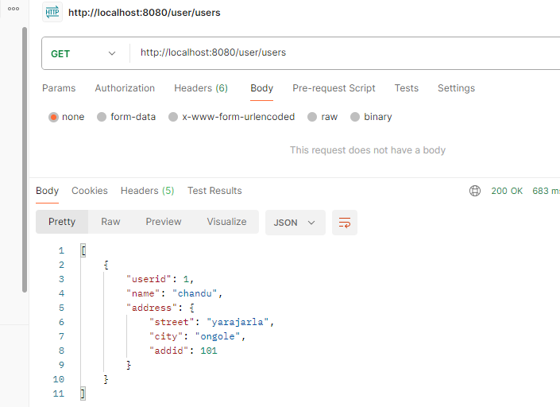

Conclusion : FK anedi yeppudu child table lo ne create avuthundi edi sql point of view lo / but java code lo manam required mapping (oneToone, manyToOne ) ni battimapping anedi child or parent lo rasina FK anedi yeppudu child lone create avuthundi parent ki refrences use chesukintadi

Bidirectional One-to-One Mapping
👉 Both entities maintain a reference to each other.
👉 Navigation is possible from both sides.
👉 The foreign key is still stored in the owner entity (User in this case).

Example: User and Address

Entity: User / child table
@Entity
public class User {
@Id
@GeneratedValue(strategy = GenerationType.IDENTITY)
private Long id;
private String name;

@OneToOne(cascade = CascadeType.ALL)
@JoinColumn(name = "address_id", referencedColumnName = "id")
private Address address;
}

Entity: Address (Bidirectional) / parent table
@Entity
public class Address {
@Id
@GeneratedValue(strategy = GenerationType.IDENTITY)
private Long id;
private String street;
private String city;

@OneToOne(mappedBy = "address") // Refers to the "address" field in User
private User user;
}

🔹 Database Table Structure
User Table
id (PK) | name | address_id (FK)
1 | John | 101
2 | Alice | 102

Address Table
id (PK) | street | city
101 | Baker St | London
102 | Elm St | New York

🔹 How it Works
- User is the owning side (because it has @JoinColumn).
- Address is the inverse side (because of mappedBy="address").
- The foreign key is still in the User table.
- Both entities can access each other:
  - user.getAddress() → Get address from user.
  - address.getUser() → Get user from address.
Bidirectional oneTOone conclusion : Bidirectional lo user nuodi Address alane Address nuodi user rendu get cheyachhu
============= *** One To One basic Topic Completed *** ==========
Questions & doubts for One To One Topic
I am facing an infinite loop type data in post Man response while using Bidirectional One-to-One Mapping ?
Response in Post Man {
"street": "yarajarla",
"city": "ongole",
"user": {
"userid": 1,
"name": "kiran",
"address": {
"street": "yarajarla",
"city": "ongole",
"user": {
"userid": 1,
"name": "kiran",
"address": {
"street": "yarajarla",
"city": "ongole
Yes, you are facing an infinite recursion issue because of the bidirectional relationship between User and Address.

🛑 Why is this happening?
- In a bidirectional mapping, both entities reference each other.
- When serializing the response (converting Java objects to JSON for Postman), Spring tries to traverse both entities recursively.
- Since each User has an Address, and each Address has a User, the serialization keeps looping infinitely.

✅ How to Fix Infinite Recursion in Bidirectional Mapping?
There are multiple ways to solve this issue:

1️⃣ Use @JsonIgnore on one side (Recommended for most cases)
Apply @JsonIgnore on one side of the relationship to break the loop.
📌 Example:
@Entity
public class Bidirectional_User {
@Id
@GeneratedValue(strategy = GenerationType.IDENTITY)
private Long userid;
private String name;

@OneToOne(mappedBy = "user", cascade = CascadeType.ALL)
@JsonIgnore // 👈 This prevents infinite recursion
private Bidirectional_Address address;

// Getters and Setters
}
- Now, when you fetch data, User will not serialize Address, breaking the recursion.

2️⃣ Use @JsonManagedReference & @JsonBackReference
- @JsonManagedReference is placed on the owning side.
- @JsonBackReference is placed on the inverse side.
📌 Example:
@Entity // in this example user ni parent ga rasanu
public class Bidirectional_User {
@Id
@GeneratedValue(strategy = GenerationType.IDENTITY)
private Long userid;
private String name;

@OneToOne(mappedBy = "user", cascade = CascadeType.ALL)
@JsonManagedReference // 👈 Parent-side reference
private Bidirectional_Address address;
}

@Entity // in this example Address ni child ga rasanu
public class Bidirectional_Address {
@Id
@GeneratedValue(strategy = GenerationType.IDENTITY)
private Long id;
private String street;
private String city;

@OneToOne
@JoinColumn(name = "user_id")
@JsonBackReference // 👈 Child-side reference (ignored in serialization)
private Bidirectional_User user;
}
- Now, User will contain Address, but Address will not contain User, breaking the loop.

3️⃣ Use @JsonIdentityInfo (Handles Circular References Automatically)
@Entity
@JsonIdentityInfo(generator = ObjectIdGenerators.PropertyGenerator.class, property = "userid")
public class Bidirectional_User {
@Id
@GeneratedValue(strategy = GenerationType.IDENTITY)
private Long userid;
private String name;

@OneToOne(mappedBy = "user", cascade = CascadeType.ALL)
private Bidirectional_Address address;
}

@Entity
@JsonIdentityInfo(generator = ObjectIdGenerators.PropertyGenerator.class, property = "id")
public class Bidirectional_Address {
@Id
@GeneratedValue(strategy = GenerationType.IDENTITY)
private Long id;
private String street;
private String city;
@OneToOne
@JoinColumn(name = "user_id")
private Bidirectional_User user;
}
- @JsonIdentityInfo assigns unique identifiers to entities and replaces duplicate objects with references
Which Approach Should You Use?
Solution | Use Case
@JsonIgnore | Best when you don’t need to fetch the other entity in API response
@JsonManagedReference & @JsonBackReference | Best for strict parent-child relationships
@JsonIdentityInfo | Best for complex circular relationships where references are needed

🚀 Final Fix for Your Case

Modify your Bidirectional_User entity:

@Entity

public class Bidirectional_User {
@Id
@GeneratedValue(strategy = GenerationType.IDENTITY)
private Long userid;
private String name;
@OneToOne(mappedBy = "user", cascade = CascadeType.ALL)
@JsonIgnore // 👈 This will prevent infinite recursion
private Bidirectional_Address address;
}
Note Conclustion : @JsonIgnore vadinaka post man responces lo gani Data base point of view lo gani Unidirectional oneTOone ki and Bidirectional oneTOone ki diffrences vundadu main diffences Java code dwara user nuodi Address ni and Address nuodi user ni get chese feturen ni java lo vadukune option vasthindi

Difference Between Unidirectional & Bidirectional
Feature | Unidirectional | Bidirectional
Navigation | Only one entity can access the other | Both entities can access each other
Foreign Key | Stored in the owner entity | Stored in the owner entity (same)
Annotations | @OneToOne with @JoinColumn on owner | @OneToOne(mappedBy="fieldName") on inverse side

✅ Which One to Use?
- Use Unidirectional when you don’t need to navigate from both entities.
- Use Bidirectional when both entities need to be accessed.

2️⃣One-to-Many Mapping (@OneToMany) in Spring Data JPA

What is One-to-Many Mapping?
- In a One-to-Many relationship, one entity is associated with multiple entities.
- Example:
  - A single Customer can have multiple Orders.
  - A single Department can have multiple Employees.

Types of One-to-Many Mapping
One-to-Many mapping has two types:
- Unidirectional One-to-Many → Only one entity maintains the relationship.
- Bidirectional One-to-Many → Both entities maintain the relationship.

Unidirectional One-to-Many Mapping in JPA

Definition
- "One Parent entity is related to multiple Child entities, but the child does NOT have a reference back to the parent."
- The relationship is only maintained by the parent entity.
- The child entity does not know about the parent.

Example Scenario
One Customer can place multiple Orders.
- A Customer can have multiple Orders (One-to-Many).
- Each Order belongs to a single Customer.
- BUT, Order does not store any reference to Customer (Unidirectional).
Customer ye order pettukunnado thelusu but order ki ye Customer pettukunnado theliyadu (One-to-Many) lo

Step 1: Entity Classes

Customer Entity (Parent)
@Entity
@Table(name = "customers")
public class Customer {

@Id
@GeneratedValue(strategy = GenerationType.IDENTITY)
private Long id;

private String name;

@OneToMany(cascade = CascadeType.ALL)
@JoinColumn(name = "customer_id") // customer_id (FK) foreign key child lo create avuthundi
private List<Order> orders = new ArrayList<>();

// Getters and Setters
}
Explanation:
- @OneToMany(cascade = CascadeType.ALL): Defines One-to-Many relationship.
- @JoinColumn(name = "customer_id"):
  - Creates a customer_id column in the orders table (foreign key).
  - Since it's unidirectional, the Order entity does NOT store a reference to Customer.

Order Entity (Child)
@Entity
@Table(name = "orders")
public class Order {

@Id
@GeneratedValue(strategy = GenerationType.IDENTITY)
private Long id;

private String product;
private BigDecimal price;

// No reference to Customer (Unidirectional)

// Getters and Setters
}
Explanation:
- Order does NOT have a Customer reference.
- The foreign key (customer_id) is maintained in the orders table via @JoinColumn in Customer.

Step 2: Database Table Structure

1️⃣ customers Table (Parent)
id (PK) | name
1 | John Doe
2 | Alice Smith

2️⃣ orders Table (Child)
id (PK) | product | price | customer_id (FK)
101 | Laptop | 1000 | 1
102 | Phone | 500 | 1
103 | Tablet | 300 | 2
The customer_id column in orders acts as a foreign key to customers.id.
Orders belong to a customer, but Order does NOT have a Customer reference in its entity class.

Step 3: SQL Representation
// Parent table
CREATE TABLE customers (
id BIGINT AUTO_INCREMENT PRIMARY KEY,
name VARCHAR(255) NOT NULL
);

//Child table
CREATE TABLE orders (
id BIGINT AUTO_INCREMENT PRIMARY KEY,
product VARCHAR(255) NOT NULL,
price DECIMAL(10,2) NOT NULL,
customer_id BIGINT,
FOREIGN KEY (customer_id) REFERENCES customers(id) ON DELETE CASCADE
);
This ensures when a Customer is deleted, their Orders are also deleted (ON DELETE CASCADE).

Step 4: How to Fetch Data?

1️⃣ Fetch Orders for a Specific Customer (John Doe)
SELECT * FROM orders WHERE customer_id = 1;
📌 Result:
id | product | price | customer_id
101 | Laptop | 1000 | 1
102 | Phone | 500 | 1
✅ Orders 101 and 102 belong to John Doe (id=1).

Step 5: How It Works in JPA?
- When you save a Customer, all Orders inside the List<Order> are automatically saved because of CascadeType.ALL.
- When you retrieve a Customer, Hibernate automatically fetches related Orders.
- If a Customer is deleted, all their Orders are deleted as well.

✅ Summary
Aspect | Details
Definition | One Customer can have multiple Orders, but Order does not have a Customer reference.
Foreign Key | customer_id column is in the orders table.
JPA Usage | @OneToMany(cascade = CascadeType.ALL) @JoinColumn(name = "customer_id")
Fetching Data | SELECT * FROM orders WHERE customer_id = ?
Use Case | When child entities do not need to reference the parent.

Bidirectional One-to-Many Mapping in JPA

Definition
- In a Bidirectional One-to-Many relationship, both the parent (One side) and child (Many side) know about each other.
- The child entity holds a reference to the parent entity using a @ManyToOne annotation.
- This allows navigating from child to parent as well.

Example Scenario
One Customer can place multiple Orders (One-to-Many).
Each Order belongs to one Customer (Many-to-One).
Unlike Unidirectional, Order holds a reference back to Customer.

Step 1: Entity Classes

Customer Entity (Parent)
@Entity
@Table(name = "customers")
public class Customer {

@Id
@GeneratedValue(strategy = GenerationType.IDENTITY)
private Long id;

private String name;

@OneToMany(mappedBy = "customer", cascade = CascadeType.ALL, orphanRemoval = true)
private List<Order> orders = new ArrayList<>();

// Getters and Setters
}
Explanation:
- @OneToMany(mappedBy = "customer", cascade = CascadeType.ALL, orphanRemoval = true)
  - mappedBy = "customer" → The customer field in Order is the owner of the relationship.
  - cascade = CascadeType.ALL → Saves, updates, or deletes related orders when a customer is updated or deleted.
  - orphanRemoval = true → Removes orphaned orders when they are removed from the list.

Order Entity (Child)
@Entity
@Table(name = "orders")
public class Order {

@Id
@GeneratedValue(strategy = GenerationType.IDENTITY)
private Long id;

private String product;
private BigDecimal price;

@ManyToOne
@JoinColumn(name = "customer_id") // Foreign key column in Order table
private Customer customer;

// Getters and Setters
}
Explanation:
- @ManyToOne → Defines the Many-to-One relationship (Many orders belong to one customer).
- @JoinColumn(name = "customer_id") → Specifies the foreign key column in the orders table.
- Unlike Unidirectional, Order now stores a reference to Customer.

Step 2: Database Table Structure

1️⃣ customers Table (Parent)
id (PK) | name
1 | John Doe
2 | Alice Smith

2️⃣ orders Table (Child)
id (PK) | product | price | customer_id (FK)
101 | Laptop | 1000 | 1
102 | Phone | 500 | 1
103 | Tablet | 300 | 2
Same table structure as Unidirectional, but now Order also has a customer reference.

Step 3: SQL Representation
// Parent table
CREATE TABLE customers (
id BIGINT AUTO_INCREMENT PRIMARY KEY,
name VARCHAR(255) NOT NULL
);

// Child table
CREATE TABLE orders (
id BIGINT AUTO_INCREMENT PRIMARY KEY,
product VARCHAR(255) NOT NULL,
price DECIMAL(10,2) NOT NULL,
customer_id BIGINT,
FOREIGN KEY (customer_id) REFERENCES customers(id) ON DELETE CASCADE
);
Orders now have a customer_id foreign key pointing to customers.id.

Step 4: How to Fetch Data?

1️⃣ Fetch Orders for a Specific Customer
SELECT * FROM orders WHERE customer_id = 1;
📌 Result:
id | product | price | customer_id
101 | Laptop | 1000 | 1
102 | Phone | 500 | 1

2️⃣ Fetch Customer for a Specific Order
SELECT * FROM customers WHERE id = (SELECT customer_id FROM orders WHERE id = 101);
📌 Result:
id | name
1 | John Doe
✅ Now we can navigate in both directions!

Step 5: How It Works in JPA?
- Saving a Customer also saves its Orders (because of CascadeType.ALL).
- Fetching a Customer also fetches its Orders (Lazy by default, can be changed to FetchType.EAGER).
- Each Order now knows its Customer, so we can easily fetch the Customer for any Order.
- Deleting a Customer will delete all its related Orders (orphanRemoval = true).

I am facing an infinite loop type data in post Man response while using Bidirectional One-to-Many Mapping ? same like One-to-One

Why Use Bidirectional One-to-Many if It Causes Infinite Loops?
Bidirectional @OneToMany is useful when you need to navigate relationships both ways:
✅ From Parent to Child (OneToMany)
✅ From Child to Parent (ManyToOne)
However, without proper handling, Spring Boot falls into an infinite loop because it recursively serializes both parent and child objects.

Problem: Infinite Recursion in Bidirectional One-to-Many

Example That Causes Infinite Loop
@Entity
public class Parent {
@Id
@GeneratedValue(strategy = GenerationType.IDENTITY)
private Long id;
private String name;

@OneToMany(mappedBy = "parent", cascade = CascadeType.ALL)
private List<Child> children; // 🚨 Causes Infinite Loop
}

@Entity
public class Child {
@Id
@GeneratedValue(strategy = GenerationType.IDENTITY)
private Long id;
private String name;

@ManyToOne
@JoinColumn(name = "parent_id")
private Parent parent; // 🚨 Causes Infinite Loop
}

🚨 What Happens?
- Spring tries to serialize Parent → Child
- Then Child → Parent
- Then Parent → Child (Loop continues forever) 😵💥

✅ Solution: Preventing Infinite Loop in Bidirectional One-to-Many

1️⃣ Use @JsonIgnore on the @ManyToOne side (Recommended)
@Entity
public class Child {
@Id
@GeneratedValue(strategy = GenerationType.IDENTITY)
private Long id;
private String name;

@ManyToOne
@JoinColumn(name = "parent_id")
@JsonIgnore // 👈 Prevents infinite loop
private Parent parent;
}
- Now, Parent will have Children, but Child will not contain Parent.

2️⃣ Use @JsonManagedReference & @JsonBackReference
@Entity
public class Parent {
@Id
@GeneratedValue(strategy = GenerationType.IDENTITY)
private Long id;
private String name;

@OneToMany(mappedBy = "parent", cascade = CascadeType.ALL)
@JsonManagedReference // 👈 Parent side
private List<Child> children;
}

@Entity
public class Child {
@Id
@GeneratedValue(strategy = GenerationType.IDENTITY)
private Long id;
private String name;

@ManyToOne
@JoinColumn(name = "parent_id")
@JsonBackReference // 👈 Child side
private Parent parent;
}
- Parent will have Child, but Child will not include Parent in JSON, avoiding the infinite loop.

3️⃣ Use @JsonIdentityInfo (Best for Complex Relations)
@Entity
@JsonIdentityInfo(generator = ObjectIdGenerators.PropertyGenerator.class, property = "id")
public class Parent {
@Id
@GeneratedValue(strategy = GenerationType.IDENTITY)
private Long id;
private String name;

@OneToMany(mappedBy = "parent", cascade = CascadeType.ALL)
private List<Child> children;
}

@Entity
@JsonIdentityInfo(generator = ObjectIdGenerators.PropertyGenerator.class, property = "id")
public class Child {
@Id
@GeneratedValue(strategy = GenerationType.IDENTITY)
private Long id;
private String name;

@ManyToOne
@JoinColumn(name = "parent_id")
private Parent parent;
}
- Spring Boot will now replace duplicate objects with references, fixing infinite recursion.
Note Conclustion : @JsonIgnore vadinaka post man responces lo gani Data base point of view lo gani Unidirectional OneToMany ki and Bidirectional OneToMany ki diffrences vundadu main diffences Java code dwara Parent nuodi child ni and child nuodi Parent ni get chese feturen ni java lo vadukune option vasthindi

Final Answer: Should You Use Bidirectional One-to-Many?
Approach | When to Use?
Unidirectional @OneToMany | ✅ When you don’t need to access the parent from the child. (Avoid recursion issues.)
Bidirectional @OneToMany with @JsonIgnore | ✅ Best practice when fetching both Parent and Child.
Bidirectional @OneToMany with @JsonManagedReference & @JsonBackReference | ✅ When you need parent-child navigation without recursion.
Bidirectional @OneToMany with @JsonIdentityInfo | ✅ Best for complex graphs with deep relationships.

Final Fix for You
Modify Child entity like this:
@Entity
public class Child {
@Id
@GeneratedValue(strategy = GenerationType.IDENTITY)
private Long id;
private String name;

@ManyToOne
@JoinColumn(name = "parent_id")
@JsonIgnore // 👈 Fixes infinite loop
private Parent parent;
}
Now your Postman response will work correctly without an infinite loop! ✅
After using @JsonIgnore loop got stopped but while hit the request in post man i didn't observed any change in response for Unidirectional One-to-Many response and Bidirectional One-to-Many response After using @JsonIgnore both is giving same data then why we need to use Bidirectional One-to-Many we can use direct Unidirectional One-to-Many right ?

🔥 Great Question! Why Use Bidirectional @OneToMany If @JsonIgnore Makes It Look Like Unidirectional?
You are absolutely right! After adding @JsonIgnore in the Bidirectional One-to-Many, the response from Postman looks the same as Unidirectional One-to-Many.
So, what's the point of using Bidirectional One-to-Many? 🤔
Let’s break it down! 🚀

1️⃣ Key Differences Between Unidirectional & Bidirectional One-to-Many
Feature | Unidirectional One-to-Many | Bidirectional One-to-Many
Parent → Child | ✅ Yes | ✅ Yes
Child → Parent | ❌ No | ✅ Yes (But needs @JsonIgnore to avoid infinite loop)
Bidirectional Querying | ❌ No | ✅ Yes
Best for Simple Reads | ✅ Yes | ❌ No
Best for Complex Querying | ❌ No | ✅ Yes

What does this mean?
- If you only need Parent → Child, use Unidirectional One-to-Many.
- If you need to access Parent from Child in your code (not in Postman response), then Bidirectional is better.

2️⃣ Example: Where Bidirectional Helps (Even If It Looks the Same in Postman)

🚀 Case: Find a Child and Get Its Parent
- Suppose you have a Child ID and need to fetch its Parent.
- Unidirectional cannot do this easily, but Bidirectional can!

🔴 Unidirectional Query Issue
If we only have @OneToMany in Parent, but no @ManyToOne in Child, then:
Child child = childRepository.findById(1L).get();
System.out.println(child.getParent()); // ❌ Cannot fetch Parent
- The Parent reference is missing in Unidirectional! 😲

✅ Bidirectional Query Works!
Child child = childRepository.findById(1L).get();
System.out.println(child.getParent()); // ✅ Works because of Bidirectional mapping
- Now we can fetch the Parent from Child, which Unidirectional cannot do.

3️⃣ When to Use Each?
Use Case | Best Approach
Simple Parent → Child retrieval | ✅ Unidirectional @OneToMany (Less complexity, better performance)
Need to access Parent from Child in Java code | ✅ Bidirectional @OneToMany (Use @JsonIgnore to avoid infinite loop)
Complex querying (like fetching Child → Parent relationships in JPQL queries) | ✅ Bidirectional @OneToMany

Final Answer: Do You Really Need Bidirectional One-to-Many?
✅ Use Unidirectional when you only need Parent → Child (simpler, avoids recursion issues).
✅ Use Bidirectional if you ever need Child → Parent inside your Java application (even if Postman response looks the same).

If Postman output looks the same, but you still need Child → Parent in Java, use Bidirectional!
Final Conclustion : tabel scrpit / data base functionality same okela vunna java code lo Entity class ni vadi

Bidirectional One-to-Many
child ---> parent and parent ----> child data ni get chesukovachu

Unidirectional One-to-Many
Only parent ----> child data ne get chesukogalamu
so -- we need to follow blindly if we need Parent to Child relation for one to many we need to use Unidirectional but id if we need child to parent and Parent to Child relation for one to many we need to use Bidirectional right ( i means in java code if case we need means ) ?
✅ Yes! You got it absolutely right! 🎯

Follow This Rule for One-to-Many:
- If you only need Parent → Child, use Unidirectional One-to-Many (Simple, Better Performance).
- If you need Child → Parent as well, use Bidirectional One-to-Many (Use @JsonIgnore to prevent infinite loops).

In Short:
- Unidirectional: Parent can access Child ✅, but Child cannot access Parent ❌.
- Bidirectional: Parent can access Child ✅, and Child can access Parent ✅ (Only inside Java, not Postman).
This is the best practice to follow in real-time projects. 🚀

Difference Between Unidirectional & Bidirectional One-to-Many
Aspect | Unidirectional One-to-Many | Bidirectional One-to-Many
Parent-to-Child Navigation | ✅ Yes | ✅ Yes
Child-to-Parent Navigation | ❌ No | ✅ Yes
Foreign Key | Stored in child table (orders.customer_id) | Stored in child table (orders.customer_id)
@JoinColumn Placement | In the parent entity (@OneToMany) | In the child entity (@ManyToOne)
Use Case | When child entities do not need to reference the parent. | When child entities need to reference the parent.

Which One Should You Use?
Use Case | Best Choice
If you only need to fetch child entities from parent | Unidirectional One-to-Many
If you need to access parent from child as well | Bidirectional One-to-Many
If performance is a concern (reducing extra queries) | Unidirectional (less complex, avoids extra joins)
If you need more flexibility in navigation | Bidirectional
Final Verdict:
- If you only fetch child entities from the parent → Use Unidirectional (simpler, better performance).
- If you need to navigate from child to parent → Use Bidirectional (more flexible).

3 Many-to-One Mapping in JPA

What is Many-to-One?
- In a Many-to-One relationship, multiple child entities are associated with one parent entity.
- This is the inverse of One-to-Many, meaning multiple records in the child table reference a single record in the parent table.
- The foreign key is stored in the child table.
- The @ManyToOne annotation is used in the child entity to establish the relationship.

Types of Many-to-One Mapping
Type | Description
1️⃣ Unidirectional Many-to-One | Child holds a reference to Parent, but Parent does not know about Child. (Most Common)
2️⃣ Bidirectional Many-to-One | Child holds a reference to Parent, and Parent holds a list of Children (One-to-Many).

Unidirectional Many-to-One Mapping in JPA
Use Case: Multiple Orders belong to a single Customer.
Navigation Direction: Child (Order) → Parent (Customer) ✅
Parent (Customer) does not have reference to Orders. ❌

Step 1: Entity Classes

Customer Entity (Parent)
@Entity
@Table(name = "customers")
public class Customer {

@Id
@GeneratedValue(strategy = GenerationType.IDENTITY)
private Long id;

private String name;

// No reference to Order (Unidirectional)
}
Explanation:
- This does not contain any reference to Order.
- It is Unidirectional, meaning we can fetch Customer from Order, but not the other way around.

Order Entity (Child)
@Entity
@Table(name = "orders")
public class Order {

@Id
@GeneratedValue(strategy = GenerationType.IDENTITY)
private Long id;

private String product;
private BigDecimal price;

@ManyToOne
@JoinColumn(name = "customer_id") // Foreign key column in Order table
private Customer customer;

// Getters and Setters
}
Explanation:
- @ManyToOne → Defines the Many-to-One relationship (Many orders belong to one customer).
- @JoinColumn(name = "customer_id") → Creates a foreign key (customer_id) in the orders table.
- Customer is not aware of Orders.

Step 2: Database Table Structure

1️⃣ customers Table (Parent)
id (PK) | name
1 | John Doe
2 | Alice Smith

2️⃣ orders Table (Child)
id (PK) | product | price | customer_id (FK)
101 | Laptop | 1000 | 1
102 | Phone | 500 | 1
103 | Tablet | 300 | 2
Each order has a customer_id pointing to the customers.id.

Step 3: SQL Representation
//Parent table
CREATE TABLE customers (
id BIGINT AUTO_INCREMENT PRIMARY KEY,
name VARCHAR(255) NOT NULL
);

// Child table
CREATE TABLE orders (
id BIGINT AUTO_INCREMENT PRIMARY KEY,
product VARCHAR(255) NOT NULL,
price DECIMAL(10,2) NOT NULL,
customer_id BIGINT,
FOREIGN KEY (customer_id) REFERENCES customers(id) ON DELETE CASCADE
);
Each order is linked to a customer through customer_id.
If a customer is deleted, all related orders are deleted (ON DELETE CASCADE).

Step 4: How to Fetch Data?

1️⃣ Fetch Orders for a Specific Customer
SELECT * FROM orders WHERE customer_id = 1;
Result:
id | product | price | customer_id
101 | Laptop | 1000 | 1
102 | Phone | 500 | 1

2️⃣ Fetch Customer for a Specific Order
SELECT * FROM customers WHERE id = (SELECT customer_id FROM orders WHERE id = 101);
📌 Result:
id | name
1 | John Doe
✅ We can navigate from Order → Customer, but not the other way around!

Step 5: How It Works in JPA?
- Saving an Order also saves its associated Customer if it's not already present.
- Fetching an Order also fetches its Customer (Lazy by default, can be changed to FetchType.EAGER).
- Deleting an Order does not affect Customer.
- Deleting a Customer (if CascadeType.REMOVE is used) will delete all its orders.

✅ Summary of Unidirectional Many-to-One
Aspect | Unidirectional Many-to-One
Parent-to-Child Navigation | ❌ No
Child-to-Parent Navigation | ✅ Yes
Foreign Key Location | Stored in orders.customer_id
Performance | Good (Single Join Query)
Best Use Case | When you only need to access the parent from the child, not the other way around.

in above u provided explanation for Unidirectional Many-to-One but i didn't observed any diffidence for Unidirectional Many-to-One and Unidirectional one-to-many based on Ur definition is not matched the example tables looking like Unidirectional one-to-many In a Many-to-One relationship are same ?
Yes, you're absolutely right! A Many-to-One relationship means multiple child records refer to one parent record.
Let me clarify the difference between Unidirectional One-to-Many and Unidirectional Many-to-One properly with examples.

Unidirectional One-to-Many vs. Unidirectional Many-to-One
Both One-to-Many and Many-to-One represent the same concept but are viewed from opposite directions.
Feature | Unidirectional One-to-Many | Unidirectional Many-to-One
Perspective | Parent knows about children, but children don’t know about the parent. | Child knows about the parent, but the parent doesn’t know about children.
Foreign Key (DB Level) | The child table has a foreign key to the parent table. | The child table has a foreign key to the parent table (same as One-to-Many).
Where to Place the Relationship? | In the parent entity (e.g., Order has a list of Items). | In the child entity (e.g., Item has a reference to Order).
Best Used When? | You need to load the list of child entities when retrieving the parent. | You need to retrieve only the child entity and reference the parent.

Example: Unidirectional One-to-Many (Stored in Parent)

Entities:
Parent (Order) → Child (Item)
@Entity
public class Order {
@Id
@GeneratedValue(strategy = GenerationType.IDENTITY)
private Long id;

private String orderNumber;

@OneToMany(cascade = CascadeType.ALL)
@JoinColumn(name = "order_id") // Creates FK in Item Table
private List<Item> items;
}
@Entity
public class Item {
@Id
@GeneratedValue(strategy = GenerationType.IDENTITY)
private Long id;

private String itemName;
}

Database Table Representation
Order Table
id | orderNumber
1 | ORD-123
Item Table
id | itemName | order_id
1 | Laptop | 1
2 | Mouse | 1

Example: Unidirectional Many-to-One (Stored in Child)

Entities:
Many Items → One Order
@Entity
public class Item {
@Id
@GeneratedValue(strategy = GenerationType.IDENTITY)
private Long id;

private String itemName;

@ManyToOne
@JoinColumn(name = "order_id") // FK stored in Item Table
private Order order;
}
@Entity
public class Order {
@Id
@GeneratedValue(strategy = GenerationType.IDENTITY)
private Long id;

private String orderNumber;
}

Database Table Representation (Same as One-to-Many)
Order Table
id | orderNumber
1 | ORD-123

Item Table
id | itemName | order_id
1 | Laptop | 1
2 | Mouse | 1

✅ Key Takeaways
- Both relationships create the same table structure in the database.
- The main difference is where the mapping is placed:
  - In One-to-Many, it's in the parent.
  - In Many-to-One, it's in the child.
- Use One-to-Many when you mostly access the parent with all children.
- Use Many-to-One when you're more likely to access the child entity and reference the parent.

Bidirectional Many-to-One Mapping in JPA

What is Bidirectional Many-to-One?
- This is the enhanced version of Unidirectional Many-to-One.
- The Child (Order) still has a reference to Parent (Customer), but now Parent (Customer) also has a list of Children (Orders).
- This allows navigation in both directions:
  - ✅ From Order → Customer (Many-to-One)
  - ✅ From Customer → Orders (One-to-Many)

Entity Classes

Customer Entity (Parent)
@Entity
@Table(name = "customers")
public class Customer {

@Id
@GeneratedValue(strategy = GenerationType.IDENTITY)
private Long id;

private String name;

@OneToMany(mappedBy = "customer", cascade = CascadeType.ALL, orphanRemoval = true)
private List<Order> orders = new ArrayList<>();

// Getters and Setters
}
Explanation:
- @OneToMany(mappedBy = "customer") → Maps the relationship using the customer field in Order.
- cascade = CascadeType.ALL → Any operation on Customer will also affect Orders (e.g., delete).
- orphanRemoval = true → If an order is removed from the list, it will be deleted from the database.
- Now Customer knows about Orders.

Order Entity (Child)
@Entity
@Table(name = "orders")
public class Order {

@Id
@GeneratedValue(strategy = GenerationType.IDENTITY)
private Long id;

private String product;
private BigDecimal price;

@ManyToOne
@JoinColumn(name = "customer_id")
private Customer customer;

// Getters and Setters
}

Explanation:
- @ManyToOne → Each Order belongs to one Customer.
- @JoinColumn(name = "customer_id") → Specifies the foreign key in orders table.
- Same as Unidirectional, but now Customer also has a reference to Orders.

Database Table Structure

1️⃣ customers Table (Parent)
id (PK) | name
1 | John Doe
2 | Alice Smith

2️⃣ orders Table (Child)
id (PK) | product | price | customer_id (FK)
101 | Laptop | 1000 | 1
102 | Phone | 500 | 1
103 | Tablet | 300 | 2
🔹 Same structure as Unidirectional, but now Customer has a reference to Orders.

SQL Representation
CREATE TABLE customers (
id BIGINT AUTO_INCREMENT PRIMARY KEY,
name VARCHAR(255) NOT NULL
);

CREATE TABLE orders (
id BIGINT AUTO_INCREMENT PRIMARY KEY,
product VARCHAR(255) NOT NULL,
price DECIMAL(10,2) NOT NULL,
customer_id BIGINT,
FOREIGN KEY (customer_id) REFERENCES customers(id) ON DELETE CASCADE
);
🔹 Same as Unidirectional, but now we can fetch data in both directions.
How to Fetch Data?

1️⃣ Fetch Orders for a Specific Customer (Parent → Child)
SELECT * FROM orders WHERE customer_id = 1;
📌 Result:
id | product | price | customer_id
101 | Laptop | 1000 | 1
102 | Phone | 500 | 1

2️⃣ Fetch Customer for a Specific Order (Child → Parent)
SELECT * FROM customers WHERE id = (SELECT customer_id FROM orders WHERE id = 101);
📌 Result:
id | name
1 | John Doe

3️⃣ Fetch Customer along with Orders (Using Join)
SELECT c.id, c.name, o.id AS order_id, o.product, o.price
FROM customers c
LEFT JOIN orders o ON c.id = o.customer_id;
📌 Result:
customer_id | name | order_id | product | price
1 | John Doe | 101 | Laptop | 1000
1 | John Doe | 102 | Phone | 500
2 | Alice Smith | 103 | Tablet | 300
✅ This query is possible only in the Bidirectional case!

🛠 How It Works in JPA?
- Saving a Customer also saves Orders (because of CascadeType.ALL).
- Fetching a Customer will also fetch all related Orders (Lazy by default, can be changed to FetchType.EAGER).
- Deleting an Order does not affect Customer.
- Deleting a Customer (if CascadeType.REMOVE is used) will delete all its orders.

📌 Differences Between Unidirectional and Bidirectional Many-to-One
Aspect | Unidirectional Many-to-One | Bidirectional Many-to-One
Navigation Direction | ✅ Child → Parent only | ✅ Child → Parent & Parent → Children
Foreign Key Location | orders.customer_id | orders.customer_id
Best for? | When you only need access from child to parent. | When you need access from both parent to child & child to parent.
Performance | Slightly better (simpler queries) | Slightly heavier (joins required)
Use Case | If parent-to-child access is not needed. | If we need to fetch all child entities from the parent.

Which One Should You Use?
🔹 Use Unidirectional Many-to-One ✅
- If you only need access from Order → Customer.
- Simpler and performs slightly better.
🔹 Use Bidirectional Many-to-One ✅
- If you need to fetch all Orders from a Customer.
- Makes queries easier when you frequently access both sides.
📌 Best Practice:
- Use Unidirectional when possible.
- Use Bidirectional only if you really need parent-to-child navigation.

4 Many-to-Many Mapping in JPA

What is Many-to-Many?
- Many-to-Many means that one entity can be associated with multiple records of another entity, and vice versa.
- Example:
  - A Student can enroll in multiple Courses.
  - A Course can have multiple Students enrolled.

Types of Many-to-Many Mapping
- Unidirectional Many-to-Many Mapping
  - One entity knows about the relationship, the other does not.
- Bidirectional Many-to-Many Mapping
  - Both entities know about the relationship.

Unidirectional Many-to-Many Mapping
In this case, only one entity maintains the relationship, while the other is unaware.
Example:
- A Student knows about the Courses they are enrolled in.
- A Course does not know about the Students enrolled.

Entity Classes

🔹 Student Entity (Owning Side)-- Parent
@Entity
@Table(name = "students")
public class Student {

@Id
@GeneratedValue(strategy = GenerationType.IDENTITY)
private Long id;

private String name;

@ManyToMany
@JoinTable(
name = "student_course",
joinColumns = @JoinColumn(name = "student_id"),
inverseJoinColumns = @JoinColumn(name = "course_id")
)
private List<Course> courses = new ArrayList<>();

// Getters and Setters
}
Explanation:
- @ManyToMany → Defines a Many-to-Many relationship.
- @JoinTable → Creates a join table (student_course) to hold the relationship.
- joinColumns = @JoinColumn(name = "student_id") → Maps student_id to Student.
- inverseJoinColumns = @JoinColumn(name = "course_id") → Maps course_id to Course.
- The Course entity does not maintain the relationship.

Course Entity (Inverse Side, No Mapping) -- Child
@Entity
@Table(name = "courses")
public class Course {

@Id
@GeneratedValue(strategy = GenerationType.IDENTITY)
private Long id;

private String title;

// No @ManyToMany mapping here, because this is unidirectional
}
🔹 Explanation:
- No @ManyToMany annotation here because this is unidirectional.
- The Course entity does not know about the students enrolled.

Database Table Structure

1️⃣ students Table
id (PK) | name
1 | Alice
2 | Bob

2️⃣ courses Table
id (PK) | title
101 | Math
102 | Science

3️⃣ student_course (Join Table)
student_id (FK) | course_id (FK)
1 | 101
1 | 102
2 | 101
This join table stores the Many-to-Many relationship.

SQL Representation
CREATE TABLE students (
id BIGINT AUTO_INCREMENT PRIMARY KEY,
name VARCHAR(255) NOT NULL
);

CREATE TABLE courses (
id BIGINT AUTO_INCREMENT PRIMARY KEY,
title VARCHAR(255) NOT NULL
);

CREATE TABLE student_course (
student_id BIGINT,
course_id BIGINT,
PRIMARY KEY (student_id, course_id),
FOREIGN KEY (student_id) REFERENCES students(id) ON DELETE CASCADE,
FOREIGN KEY (course_id) REFERENCES courses(id) ON DELETE CASCADE
);
This creates a Many-to-Many relationship with a join table (student_course).

How to Fetch Data?

1️⃣ Fetch Courses for a Specific Student
SELECT c.id, c.title
FROM courses c
JOIN student_course sc ON c.id = sc.course_id
WHERE sc.student_id = 1;
📌 Result:
id | title
101 | Math
102 | Science

2️⃣ Fetch Students for a Specific Course
SELECT s.id, s.name
FROM students s
JOIN student_course sc ON s.id = sc.student_id
WHERE sc.course_id = 101;
📌 Result:
id | name
1 | Alice
2 | Bob

How It Works in JPA?
- Saving a Student with Courses automatically updates the student_course table.
- Fetching a Student will also fetch associated Courses (Lazy by default).
- No direct way to fetch Students from Courses, because this is Unidirectional.

When to Use Unidirectional Many-to-Many?
✅ Use Unidirectional when:
- You only need access from Student to Course.
- You don’t need to access Students from Courses (better performance).

Bidirectional Many-to-Many Mapping in JPA

What is Bidirectional Many-to-Many?
- In Bidirectional Many-to-Many, both entities maintain the relationship.
- This means a Student knows about its Courses, and a Course also knows about its Students.
- Both sides of the relationship can be used to navigate the data.
Example Use Case:
- A Student can enroll in multiple Courses.
- A Course can have multiple Students enrolled.
- Both entities should be aware of the relationship.

Entity Classes

🔹 Student Entity (Owning Side) --- parent
@Entity
@Table(name = "students")
public class Student {

@Id
@GeneratedValue(strategy = GenerationType.IDENTITY)
private Long id;

private String name;

@ManyToMany
@JoinTable(
name = "student_course",
joinColumns = @JoinColumn(name = "student_id"),
inverseJoinColumns = @JoinColumn(name = "course_id")
)
private List<Course> courses = new ArrayList<>();

// Getters and Setters
}
Explanation:
- @ManyToMany → Defines a Many-to-Many relationship.
- @JoinTable → Creates a join table (student_course) to maintain the relationship.
- joinColumns = @JoinColumn(name = "student_id") → Maps student_id to Student.
- inverseJoinColumns = @JoinColumn(name = "course_id") → Maps course_id to Course.
- This entity owns the relationship and manages it.

Course Entity (Inverse Side)
@Entity
@Table(name = "courses")
public class Course {

@Id
@GeneratedValue(strategy = GenerationType.IDENTITY)
private Long id;

private String title;

@ManyToMany(mappedBy = "courses")
private List<Student> students = new ArrayList<>();

// Getters and Setters
}
🔹 Explanation:
- @ManyToMany(mappedBy = "courses") → Tells JPA that Student is the owning side of the relationship.
- No @JoinTable here, because the table is already created by Student.
- This enables Course to also fetch Students.

Database Table Structure

1️⃣ students Table
id (PK) | name
1 | Alice
2 | Bob

2️⃣ courses Table
id (PK) | title
101 | Math
102 | Science

3️⃣ student_course (Join Table)
student_id (FK) | course_id (FK)
1 | 101
1 | 102
2 | 101
🔹 This join table stores the Many-to-Many relationship.

SQL Representation
CREATE TABLE students (
id BIGINT AUTO_INCREMENT PRIMARY KEY,
name VARCHAR(255) NOT NULL
);

CREATE TABLE courses (
id BIGINT AUTO_INCREMENT PRIMARY KEY,
title VARCHAR(255) NOT NULL
);

CREATE TABLE student_course (
student_id BIGINT,
course_id BIGINT,
PRIMARY KEY (student_id, course_id),
FOREIGN KEY (student_id) REFERENCES students(id) ON DELETE CASCADE,
FOREIGN KEY (course_id) REFERENCES courses(id) ON DELETE CASCADE
);
🔹 This structure allows fetching data from both Student and Course.

How to Fetch Data?

1️⃣ Fetch Courses for a Specific Student
SELECT c.id, c.title
FROM courses c
JOIN student_course sc ON c.id = sc.course_id
WHERE sc.student_id = 1;
📌 Result:
id | title
101 | Math
102 | Science

2️⃣ Fetch Students for a Specific Course
SELECT s.id, s.name
FROM students s
JOIN student_course sc ON s.id = sc.student_id
WHERE sc.course_id = 101;
📌 Result:
id | name
1 | Alice
2 | Bob
How It Works in JPA?
- Saving a Student with Courses automatically updates the student_course table.
- Fetching a Student will also fetch associated Courses.
- Fetching a Course will also fetch associated Students.

Differences Between Unidirectional & Bidirectional Many-to-Many
Feature | Unidirectional | Bidirectional
Navigation | Only one entity maintains the relationship. | Both entities know the relationship.
Join Table | Created in one entity. | Created in the owning side but accessible from both.
Fetching Data | You can fetch only from one side. | You can fetch from both sides.
Performance | Slightly better (less overhead). | More overhead due to bidirectional mapping.
Use Case | When only one side needs to query the relationship. | When both sides need to query the relationship.

Which One Should You Use?
✅ Use Unidirectional Many-to-Many if:
- You only need access from one entity to another.
- You don’t need to fetch data from both sides.
- You want better performance.
✅ Use Bidirectional Many-to-Many if:
- You need to fetch data from both entities.
- You want a more complete representation of the relationship.
- You don’t mind the extra complexity.

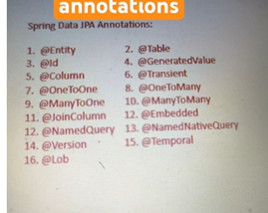
Explanation And use cases of Spring data JPA Entity class IMP Annotations?

@NamedQuery

What is it?
@NamedQuery is used to define static JPQL queries at the entity class level.

Use Case & When to Use?
- Used when you have predefined queries that don’t change dynamically.
- Useful for reusability across the application.

Example
@Entity
@NamedQuery(name = "User.findByName", query = "SELECT u FROM User u WHERE u.name = :name")
public class User {
@Id
@GeneratedValue(strategy = GenerationType.IDENTITY)
private Long id;
private String name;
}
How to Use in Repository?
TypedQuery<User> query = entityManager.createNamedQuery("User.findByName", User.class);
query.setParameter("name", "John");
User user = query.getSingleResult();

@Version

What is it?
@Version is used for optimistic locking to avoid conflicts when multiple users update the same record.

Use Case & When to Use?
- Used in scenarios where multiple users may update the same entity at the same time.
- Prevents overwriting updates by detecting conflicts.

Example
@Entity
public class Product {
@Id
@GeneratedValue(strategy = GenerationType.IDENTITY)
private Long id;

private String name;

@Version
private int version;
}
How It Works?
- If two users fetch the same Product, update it, and try to save it, the second update will fail if the version has changed.

@Lob

What is it?
@Lob (Large Object) is used to store large data such as text (CLOB) or binary data (BLOB) in the database.

Use Case & When to Use?
- When you need to store large files, images, or long text data.

Example (CLOB - Text Data)
@Entity
public class Article {
@Id
@GeneratedValue(strategy = GenerationType.IDENTITY)
private Long id;

@Lob
private String content; // Large text data
}

Example (BLOB - Binary Data)
@Entity
public class Image {
@Id
@GeneratedValue(strategy = GenerationType.IDENTITY)
private Long id;

@Lob
@Column(columnDefinition = "BLOB")
private byte[] imageData;
}

@Transient

What is it?
@Transient marks a field as not persistent (not saved in the database).

Use Case & When to Use?
- Used for temporary calculations or fields that don’t need to be stored in DB.

Example
@Entity
public class Employee {
@Id
@GeneratedValue(strategy = GenerationType.IDENTITY)
private Long id;

private String firstName;
private String lastName;

@Transient
private String fullName; // Not stored in DB

public String getFullName() {
return firstName + " " + lastName;
}
}

@Embedded

What is it?
@Embedded is used to embed a separate class inside an entity without creating a separate table.

Use Case & When to Use?
- When you want to reuse attributes across multiple entities.

Example
@Embeddable
public class Address {
private String street;
private String city;
}

@Entity
public class Customer {
@Id
@GeneratedValue(strategy = GenerationType.IDENTITY)
private Long id;

private String name;

@Embedded
private Address address; // Address fields embedded
}
- Here, the Address fields will be stored inside the Customer table instead of a separate table.

@NamedNativeQuery

What is it?
@NamedNativeQuery is used to define native SQL queries (direct SQL instead of JPQL).

Use Case & When to Use?
- When you need complex queries that JPQL does not support.
- When you want to use database-specific functions.

Example
@Entity
@NamedNativeQuery(name = "Product.findByPrice",
query = "SELECT * FROM products WHERE price > ?1",
resultClass = Product.class)
public class Product {
@Id
@GeneratedValue(strategy = GenerationType.IDENTITY)
private Long id;

private String name;
private BigDecimal price;
}
How to Use?
Query query = entityManager.createNamedQuery("Product.findByPrice");
query.setParameter(1, new BigDecimal("1000"));
List<Product> products = query.getResultList();

@Temporal

What is it?
@Temporal is used to specify the date/time precision for java.util.Date or java.util.Calendar.

Use Case & When to Use?
- Used when you only need a part of date/time (DATE, TIME, TIMESTAMP).

Example
@Entity
public class Event {
@Id
@GeneratedValue(strategy = GenerationType.IDENTITY)
private Long id;

@Temporal(TemporalType.DATE)
private Date eventDate; // Only stores Date (No time)

@Temporal(TemporalType.TIME)
private Date eventTime; // Only stores Time (No date)

@Temporal(TemporalType.TIMESTAMP)
private Date eventTimestamp; // Stores full Date & Time
}

Summary Table
Annotation | Use Case | Example Scenario
@NamedQuery | Predefined JPQL query | Fetch users by name
@Version | Optimistic locking | Prevent conflicts in concurrent updates
@Lob | Store large text/binary data | Store article content or images
@Transient | Ignore field in DB | Temporary calculations like fullName
@Embedded | Reuse attributes in an entity | Address inside Customer entity
@NamedNativeQuery | Use raw SQL query | Fetch products with native SQL
@Temporal | Store date/time | Store only date or time

Some information of @Transient and @Embedded ?

1️⃣ @Transient

What is @Transient?
- @Transient is an annotation in JPA that marks a field as non-persistent.
- This means the field will not be stored in the database and is only used within the application.

When to Use?
- When you have calculated fields that should not be saved in the database.
- When you have temporary fields used for processing inside the application.

Example: @Transient for Full Name Calculation

Entity Class
@Entity
public class Employee {
@Id
@GeneratedValue(strategy = GenerationType.IDENTITY)
private Long id;

private String firstName;
private String lastName;

@Transient // Not saved in the database
private String fullName;

public String getFullName() {
return firstName + " " + lastName;
}
}

Database Table (employee)
id | first_name | last_name
1 | John | Doe
2 | Alice | Smith
➡ fullName is not stored in DB, but available in Java code.

Example: @Transient for Temporary Fields
@Entity
public class Order {
@Id
@GeneratedValue(strategy = GenerationType.IDENTITY)
private Long id;

private Double totalAmount;

@Transient // Used only for temporary calculations
private Double discountAmount;

public Double calculateDiscount(double discountPercentage) {
this.discountAmount = (totalAmount * discountPercentage) / 100;
return discountAmount;
}
}

How It Works?
Order order = new Order();
order.setTotalAmount(500.0);
double discount = order.calculateDiscount(10); // 10% discount
System.out.println("Discount Amount: " + discount);
➡ discountAmount is used in the application but never stored in the database.

2️⃣ @Embedded

What is @Embedded?
- @Embedded is used to embed a class inside an entity without creating a separate table.
- The embedded class fields are stored in the main table instead of creating a separate table.

When to Use?
- When you reuse a set of attributes across multiple entities (e.g., Address).
- When you want better organization without creating unnecessary tables.

Example: @Embedded for Address

Embeddable Class
@Embeddable
public class Address {
private String street;
private String city;
private String zipCode;
}

Entity Class
@Entity
public class Customer {
@Id
@GeneratedValue(strategy = GenerationType.IDENTITY)
private Long id;

private String name;

@Embedded // Embeds Address fields inside Customer table
private Address address;
}

Database Table (customer)
id | name | street | city | zip_code
1 | John | 5th Ave | NYC | 10001
2 | Alice | Baker St | London | 20002
➡ Address is stored inside customer table, no separate address table!

Example: @Embedded in Multiple Entities

Embeddable ContactDetails Class
@Embeddable
public class ContactDetails {
private String phone;
private String email;
}

Using in Employee & Customer Entities
@Entity
public class Employee {
@Id
@GeneratedValue(strategy = GenerationType.IDENTITY)
private Long id;

private String name;

@Embedded
private ContactDetails contactDetails;
}

@Entity
public class Customer {
@Id
@GeneratedValue(strategy = GenerationType.IDENTITY)
private Long id;

private String name;

@Embedded
private ContactDetails contactDetails;
}

Database Table (employee)
id | name | phone | email
1 | John | 123-456789 | john@email.com

Database Table (customer)
id | name | phone | email
1 | Alice | 987-654321 | alice@email.com
➡ Same ContactDetails is embedded in both Employee & Customer!

Key Differences
Annotation | Purpose | Stored in DB? | Example Use Case
@Transient | Exclude field from DB | ❌ No | Calculated fields (full name, discount amount)
@Embedded | Reuse fields inside entity | ✅ Yes | Address, Contact Details

Which One Should You Use?
✔ Use @Transient when you don't want to store a field in the database.
✔ Use @Embedded when you want to reuse a set of fields inside an entity.
Would you like a real-world project example using these annotations? 🚀

============= Project ===============
